Postgresql Training Exercise – 1

1. Create a user with only database create access rights.
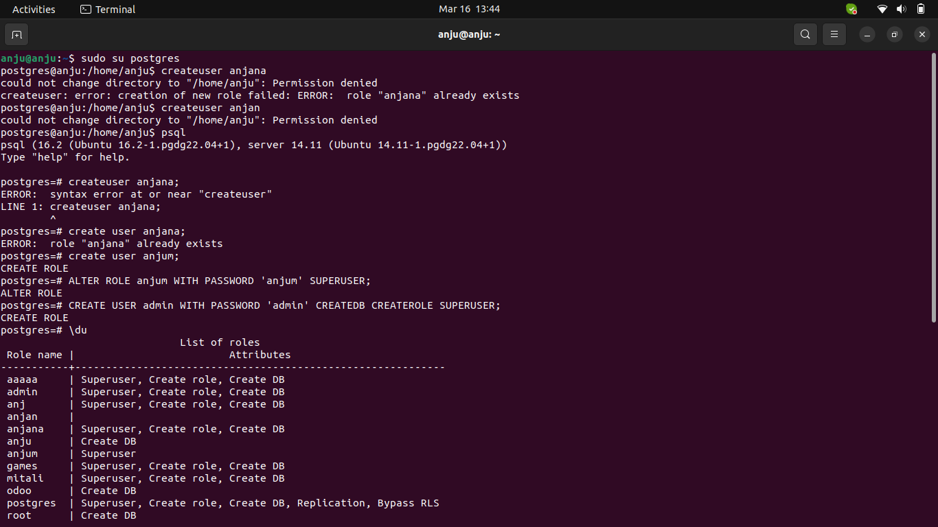

2. Create a user with superuser access rights.
3. Create a user with database creation, superuser and role creation access rights.
4. Drop any one of the users which you have created.
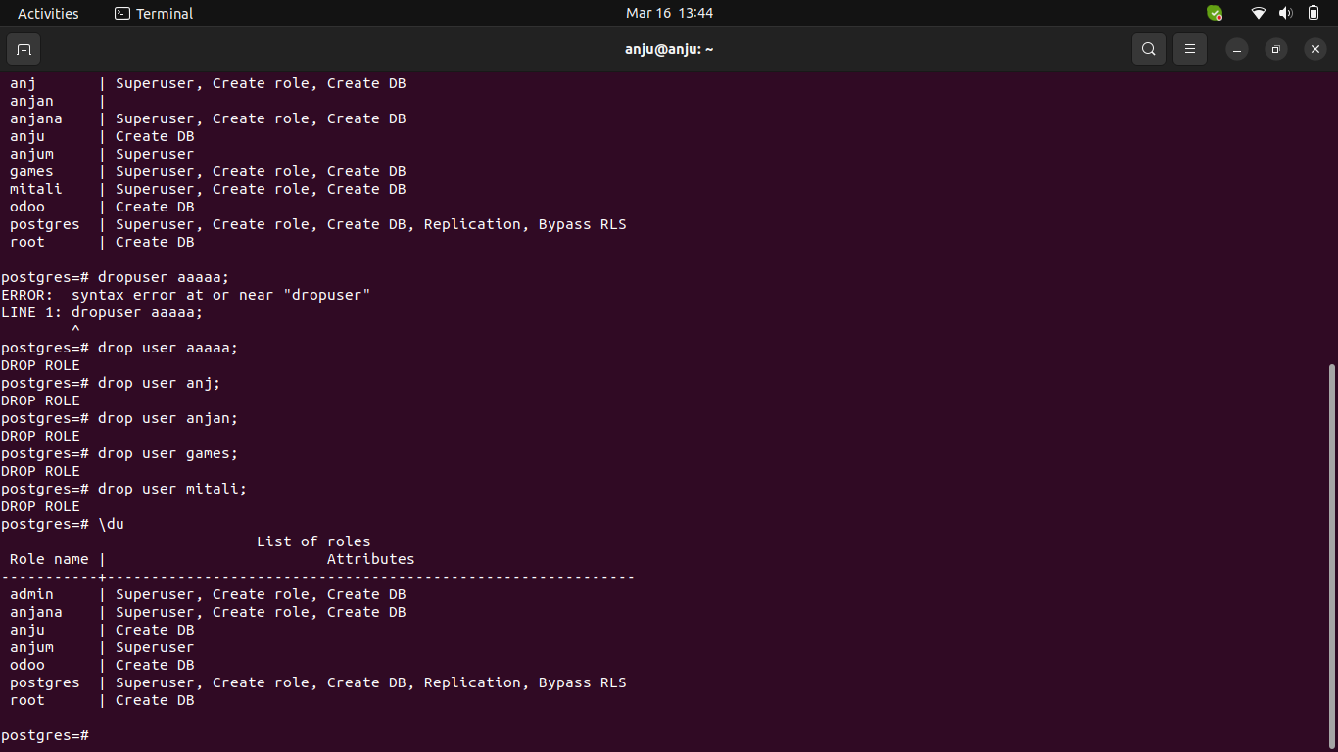

5. Alter any one user’s password with your desired password.
6. Create a database.
7. Delete a database which is created.

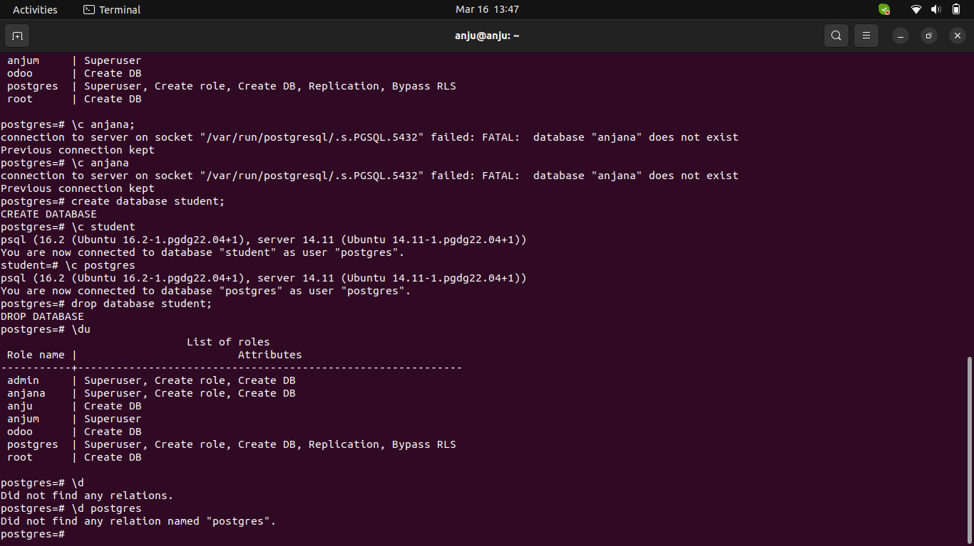
NOTE : All the below operations are to be performed in the terminal prompt of PosgreSQL and pgAdmin.

8. Create a database and add a table employee with specified fields.
◦ Employee ID
◦ Name
◦ Email
◦ Phone no
◦ Designation
◦ Department
◦ Birth Date
◦ Join Date

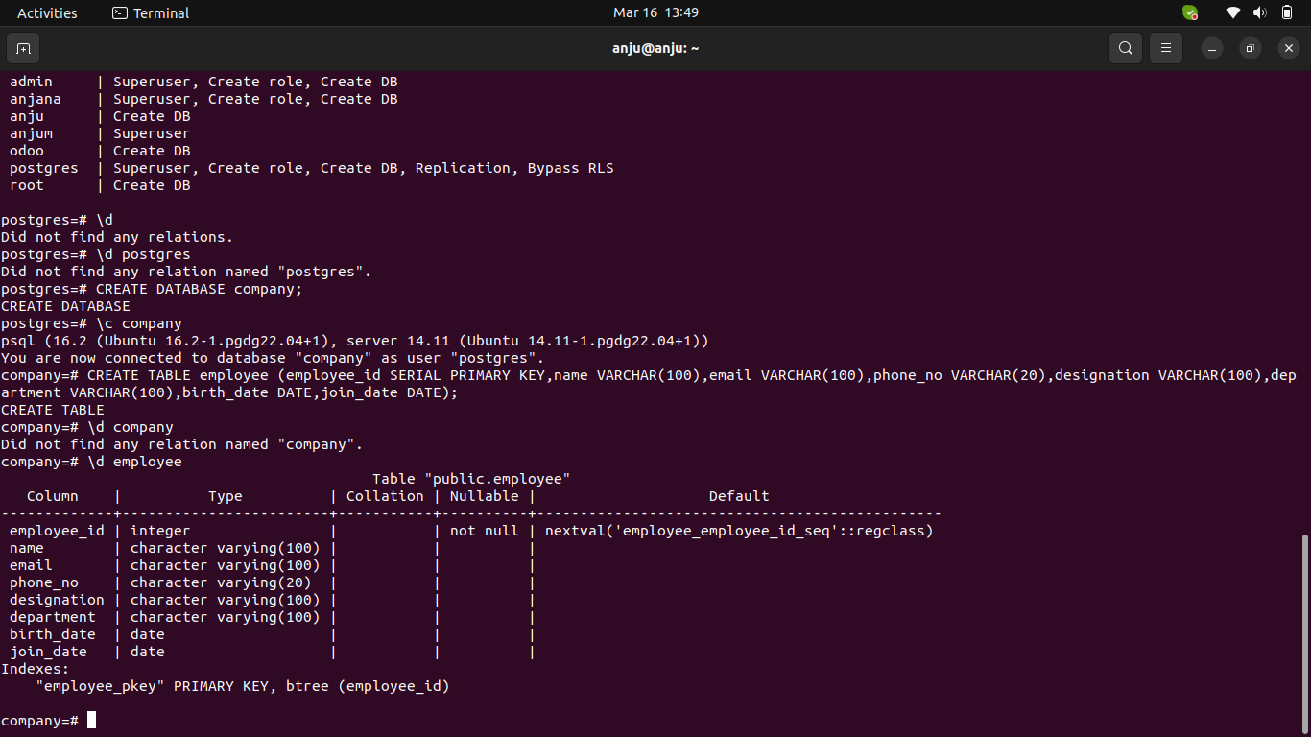
9. Modify the table and add two fields as following.
◦ Level
◦ Qualification
◦ Join Date

10. Modify a table and Delete a column from the table.

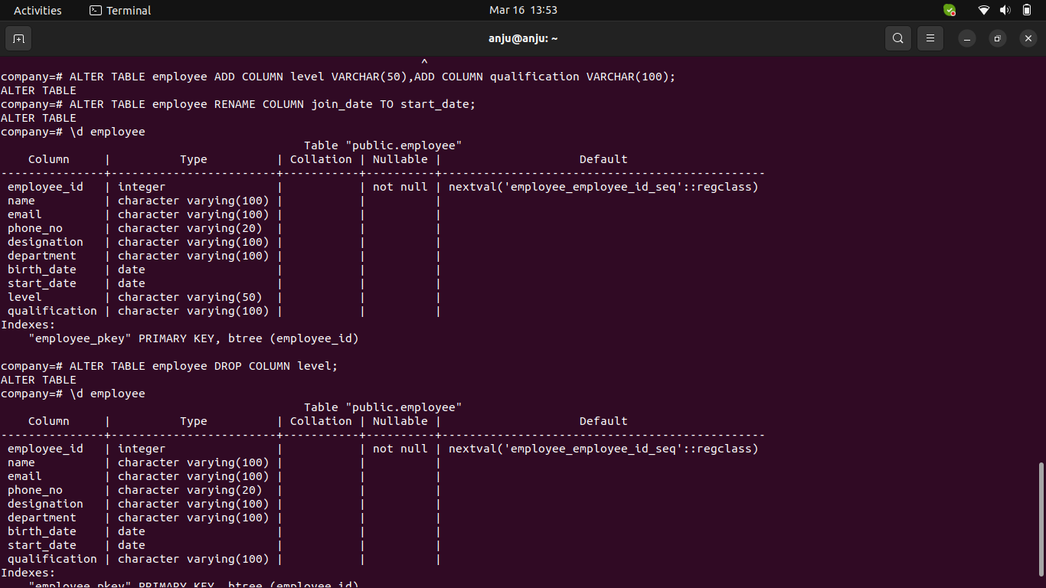
11. Insert 10 records with unique employee ids in the employee table.

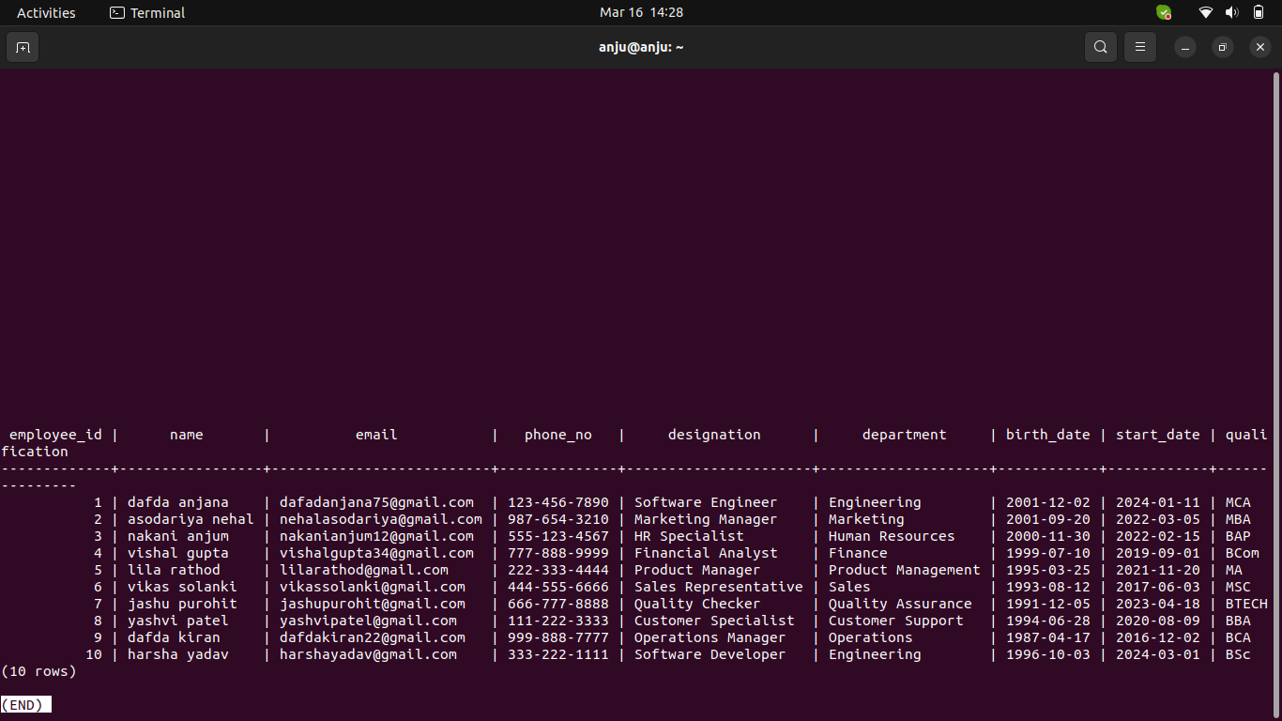
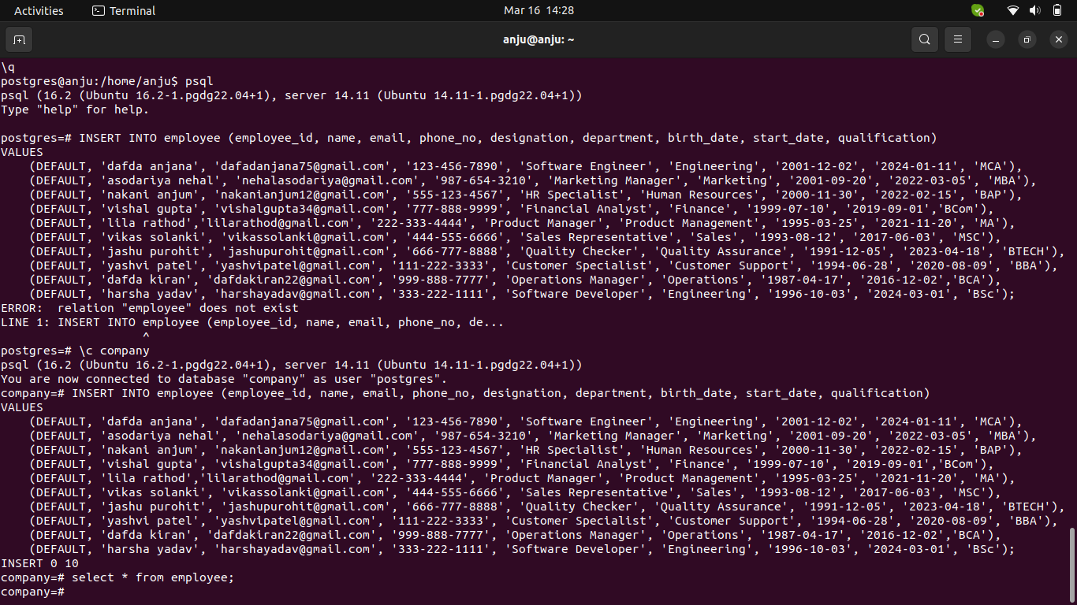
12. Update all the records together. Update only one field.
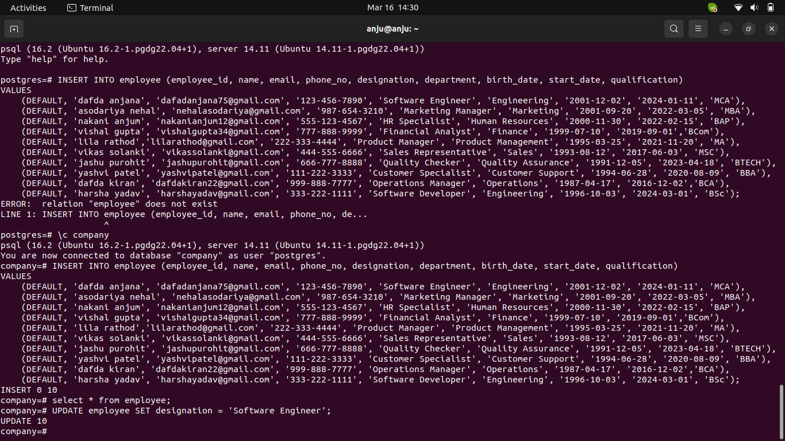
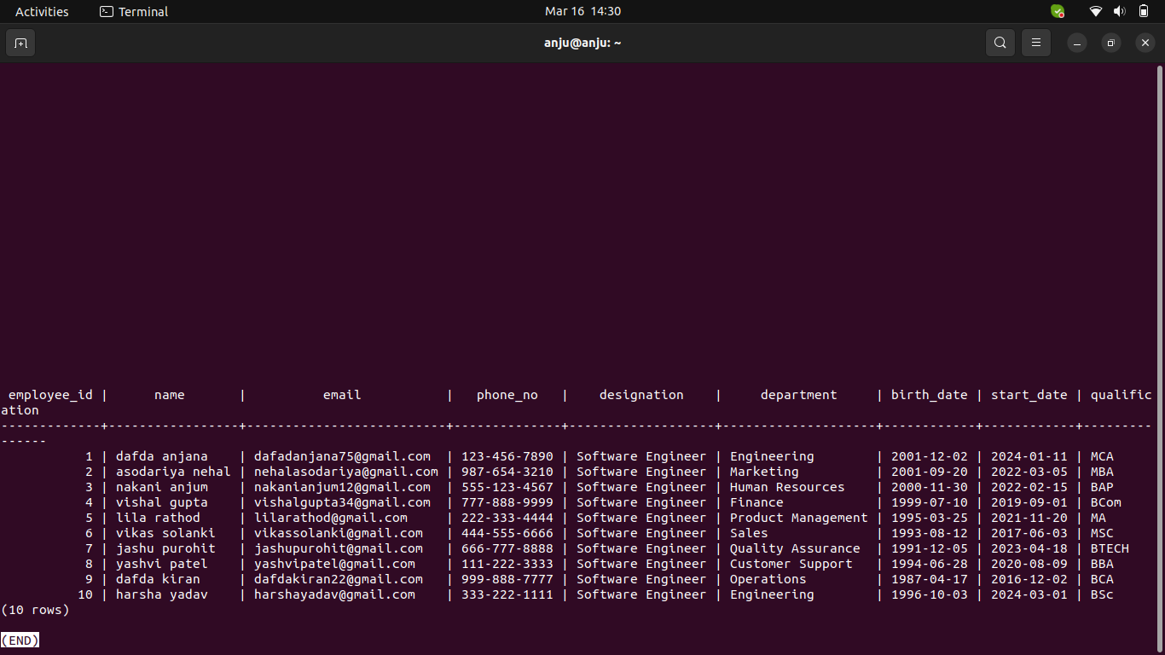
13. Delete a single record from a table.
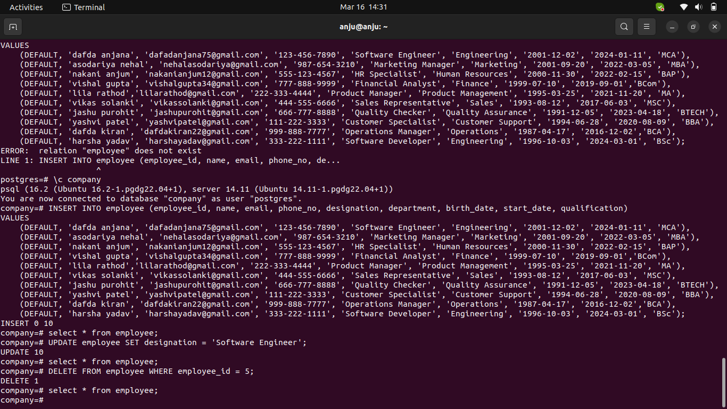
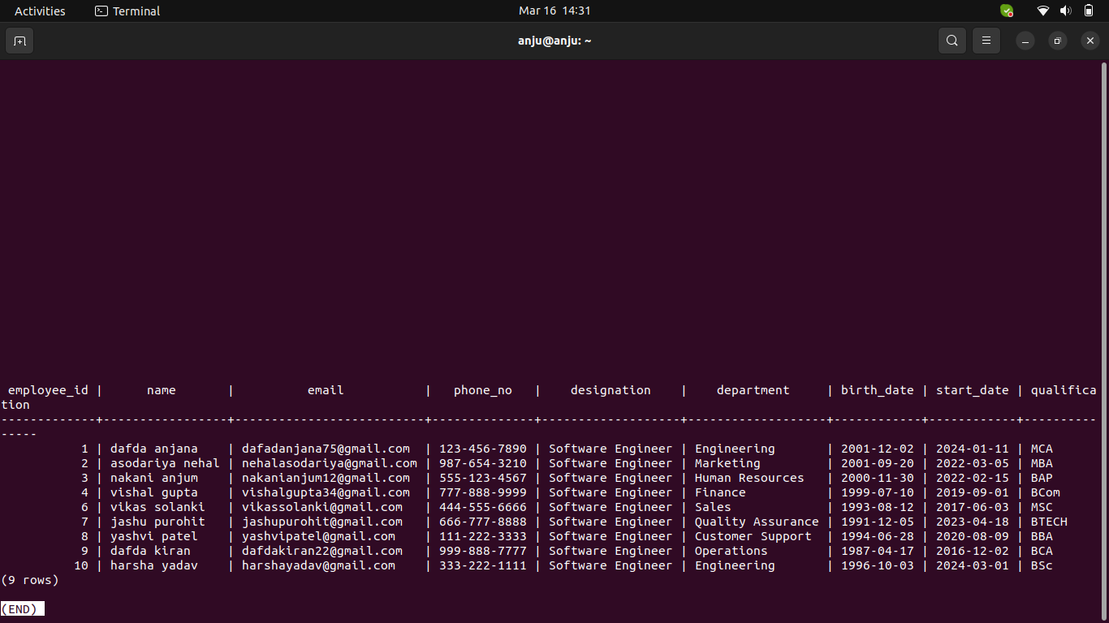
14. Delete all the records from a table using Delete.
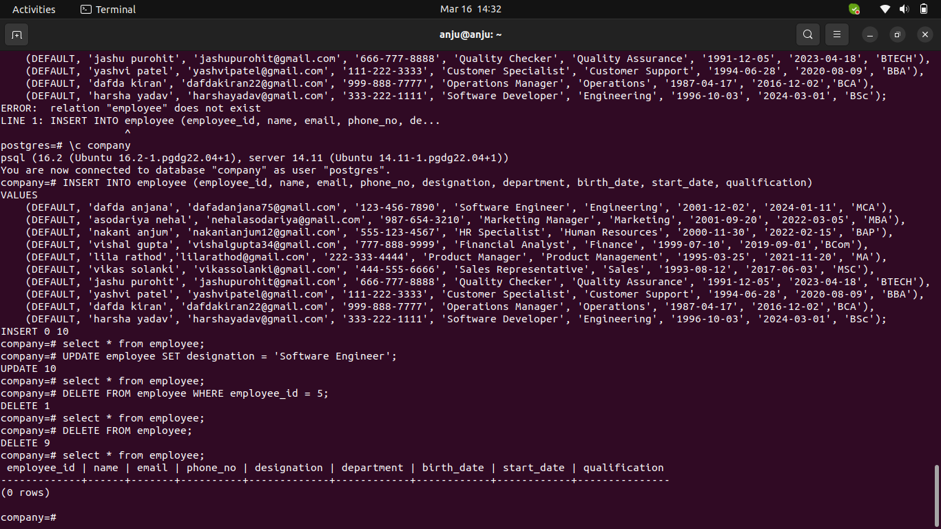
15. Delete all the records from a table without using Delete.
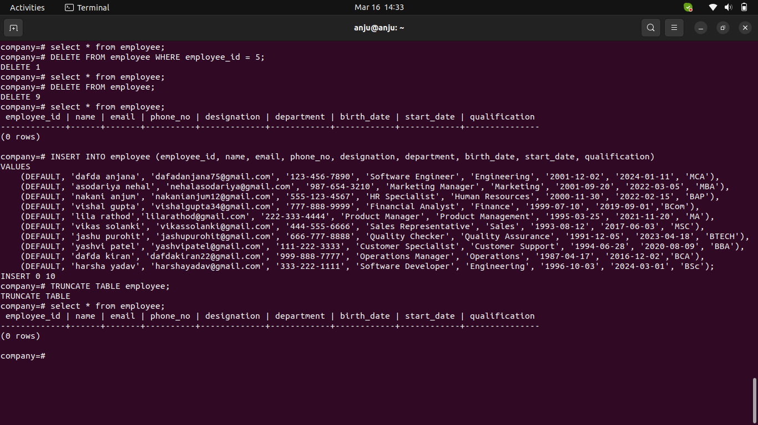
NOTE: Below operations to be done from pgAdmin GUI.

16. Create a table using the Create script in pgAdmin.
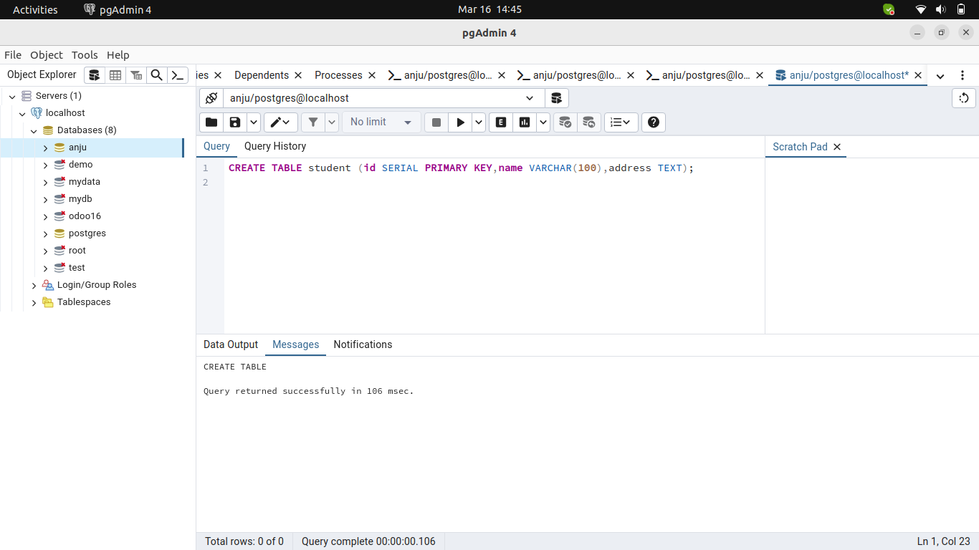
17. Insert 10 records using the Insert script in pgAdmin.
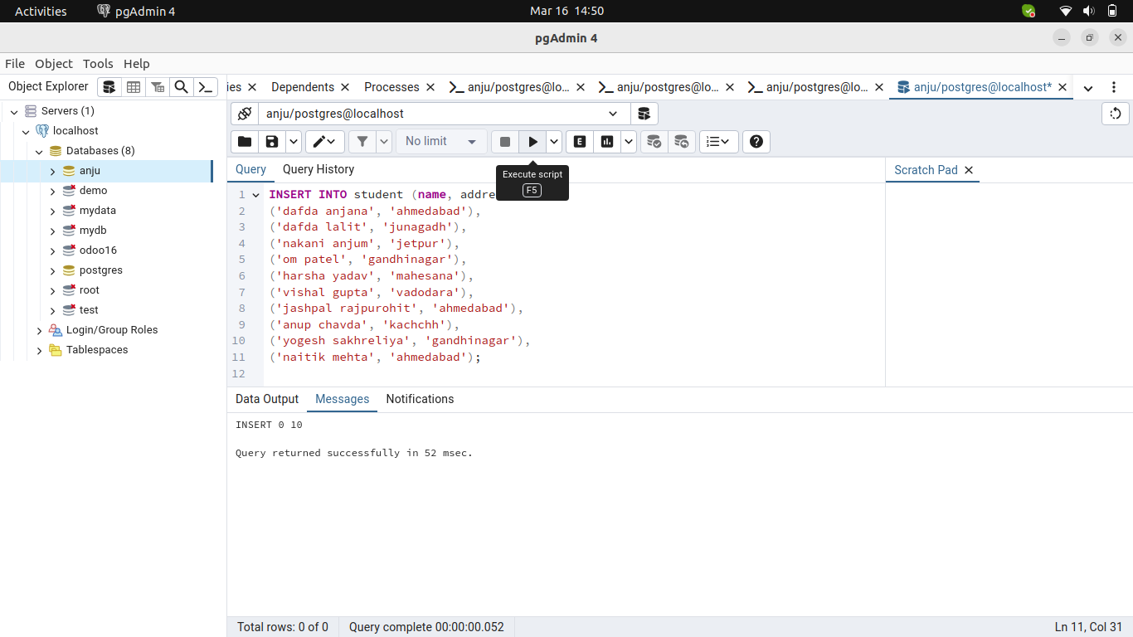
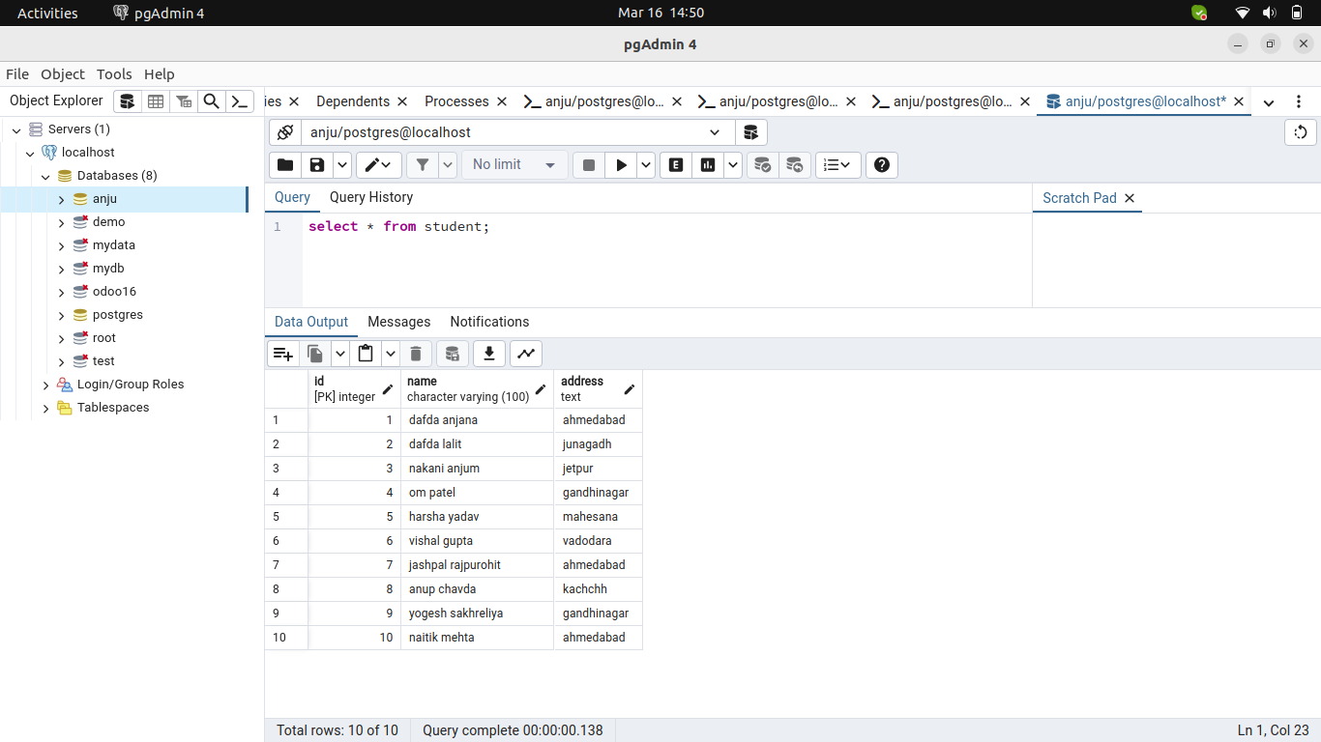
18. Update a record using the Update script in pgAdmin.
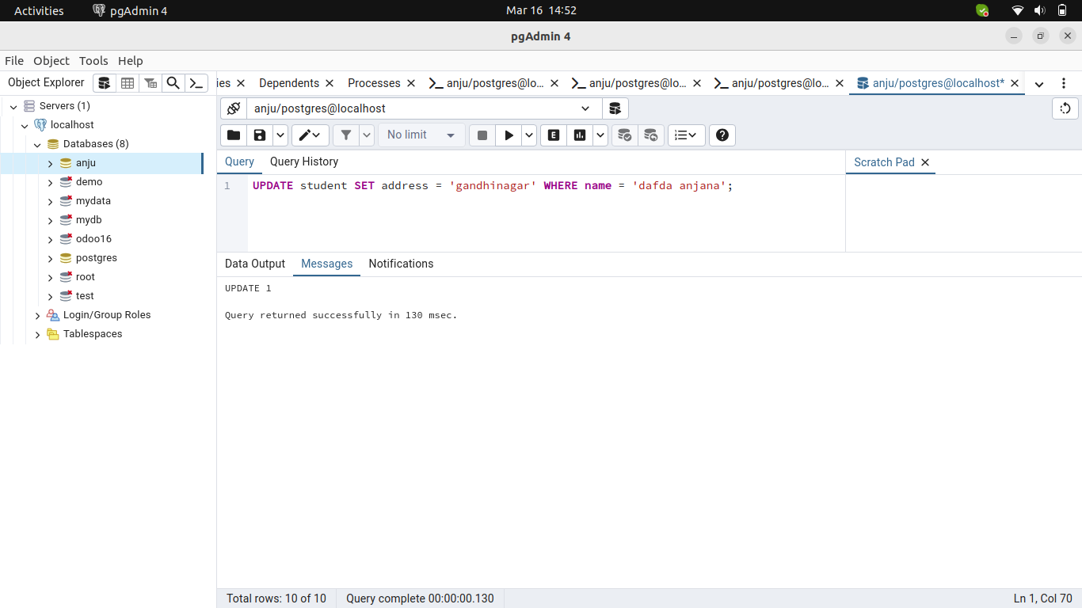
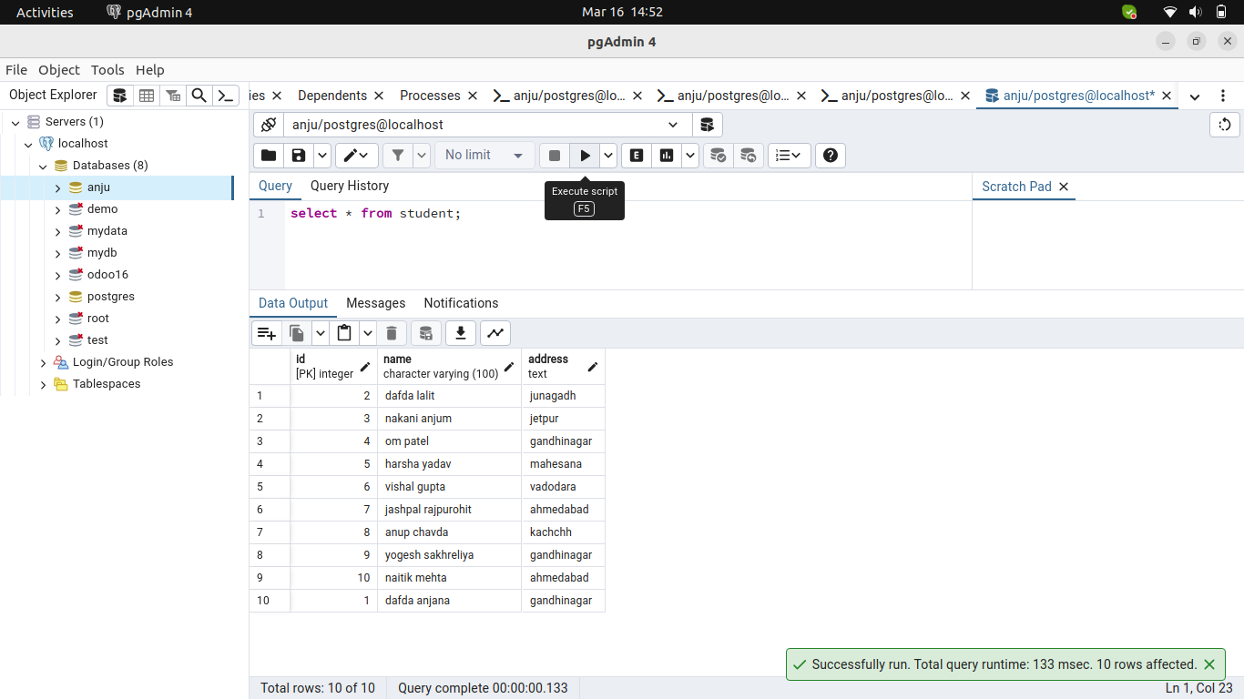
19. Delete a record using the Delete script in pgAdmin.
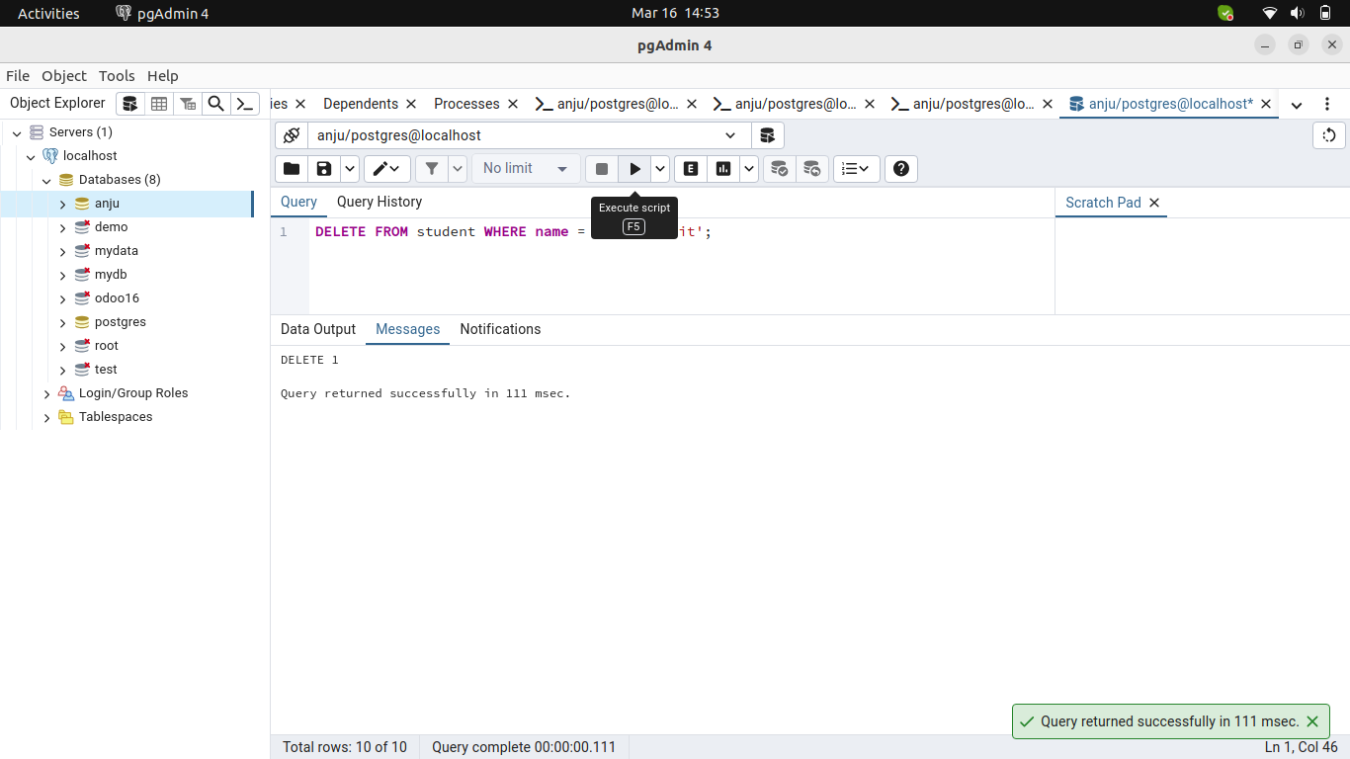
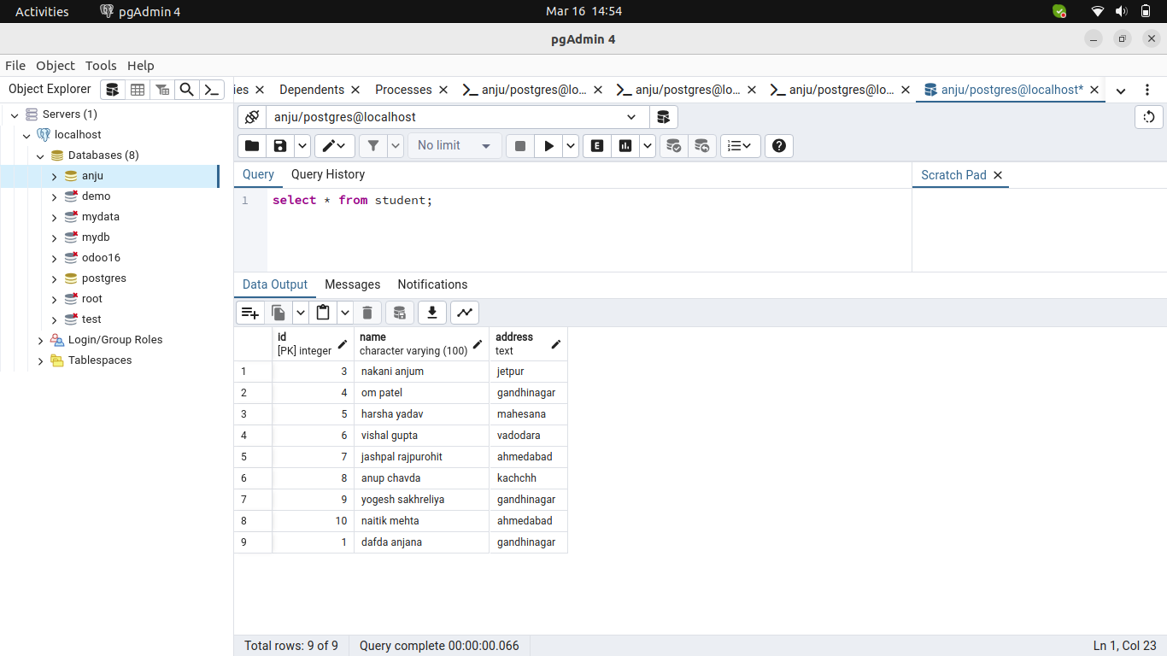
20. Create a table from the Pgadmin.
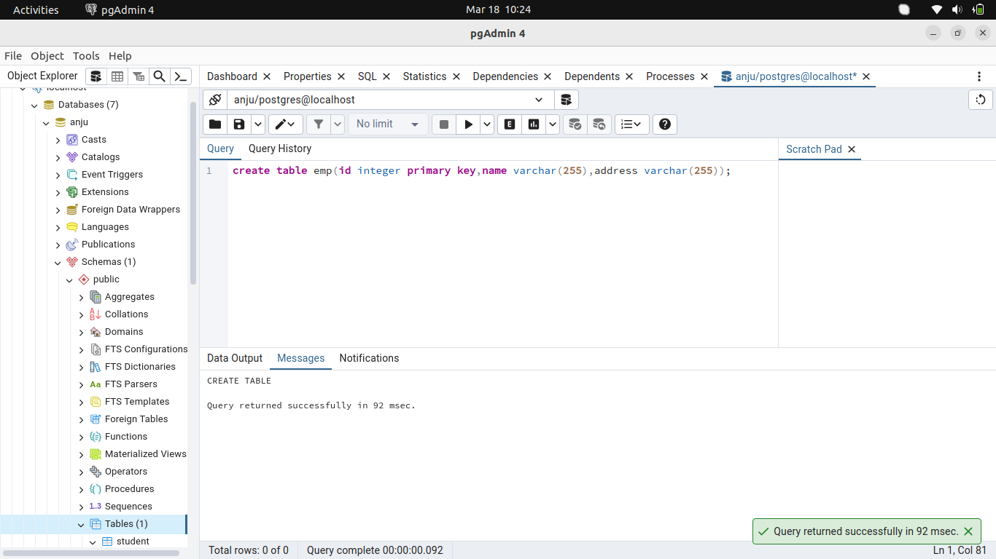
21. Update a table and add a column from pgAdmin.
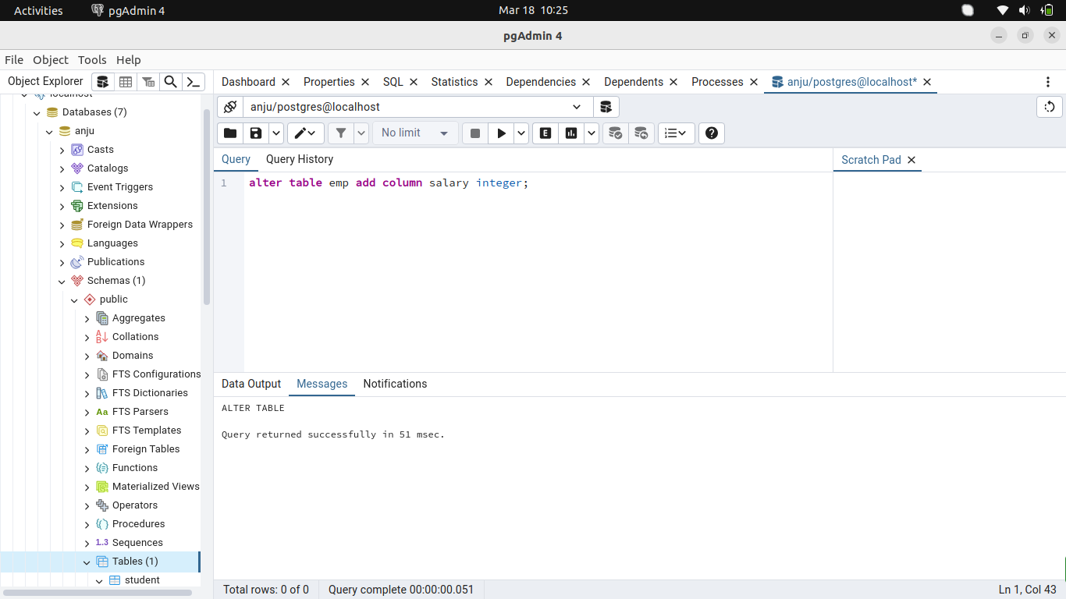
22. Remove a column from a table from pgAdmin.
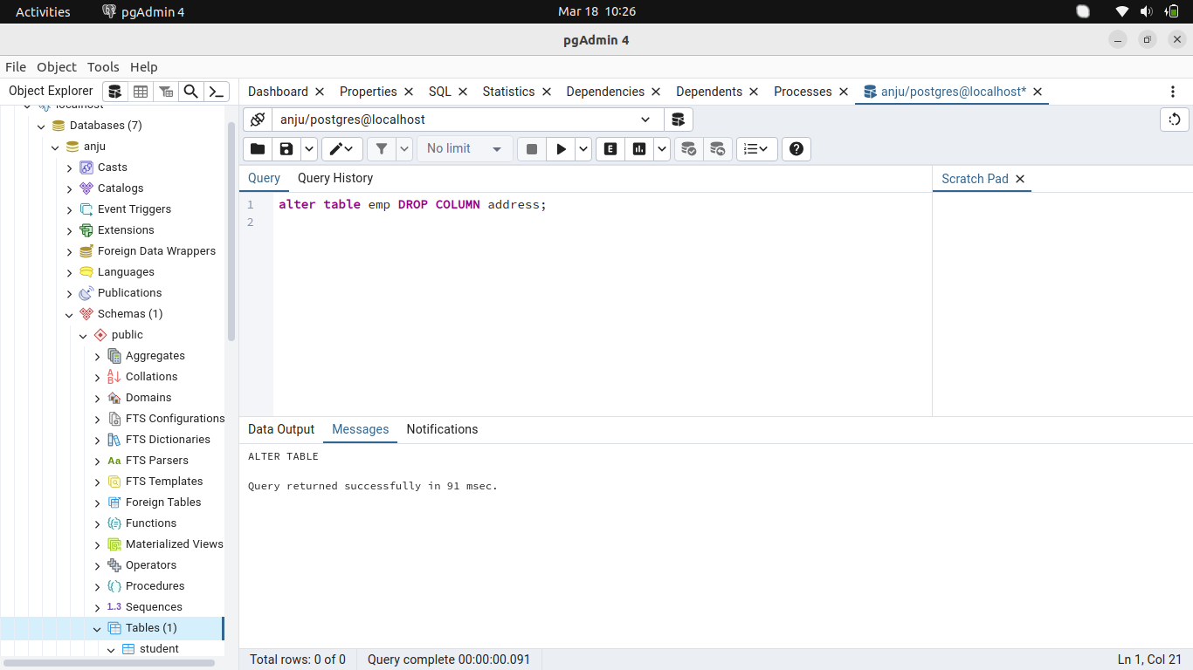
23. Update record from the Pgadmin.
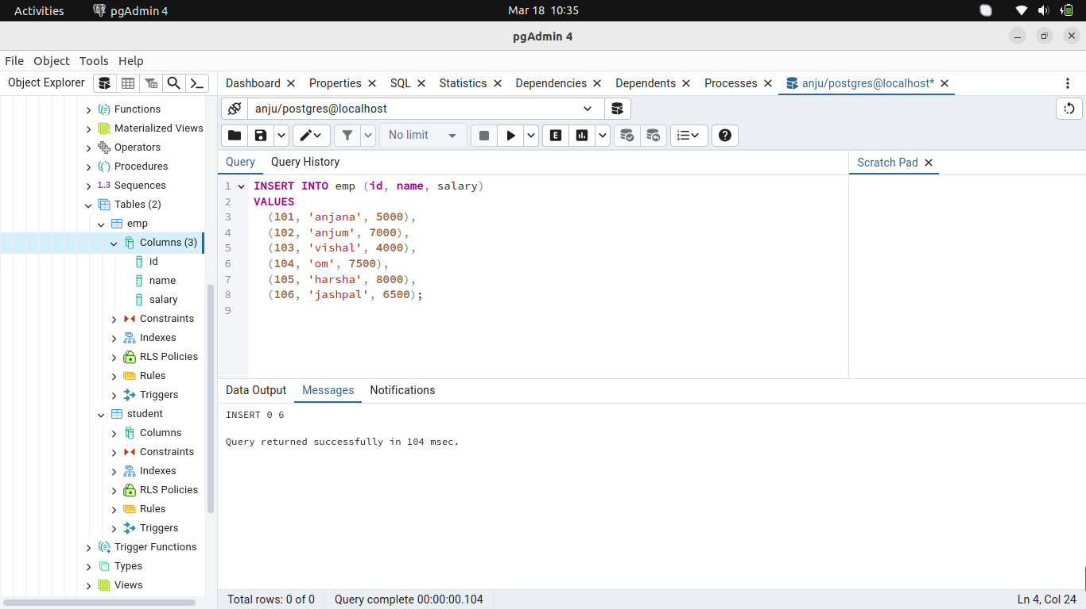
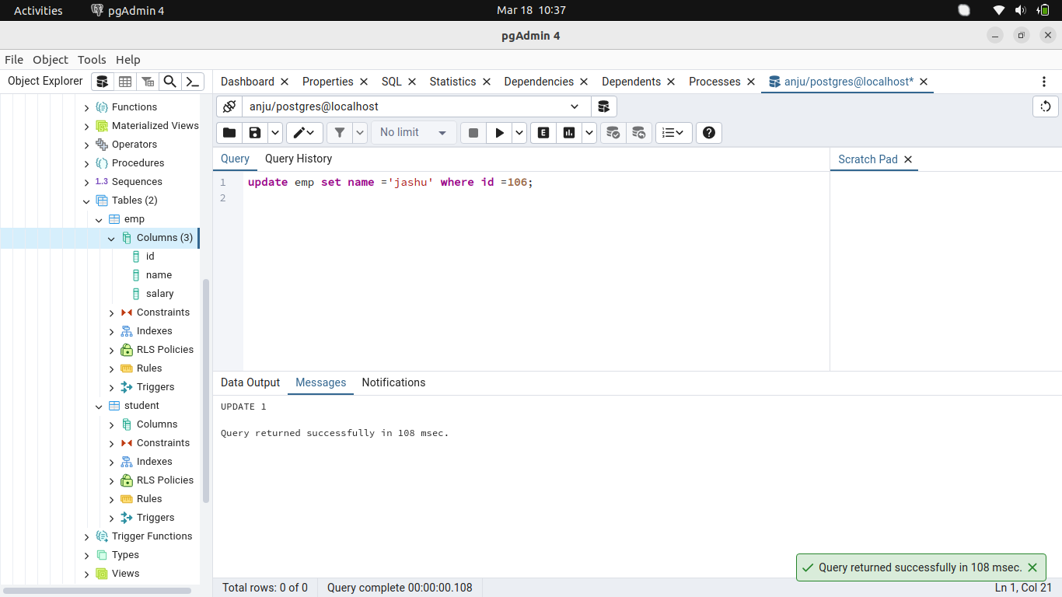
24. View all the records of a table.
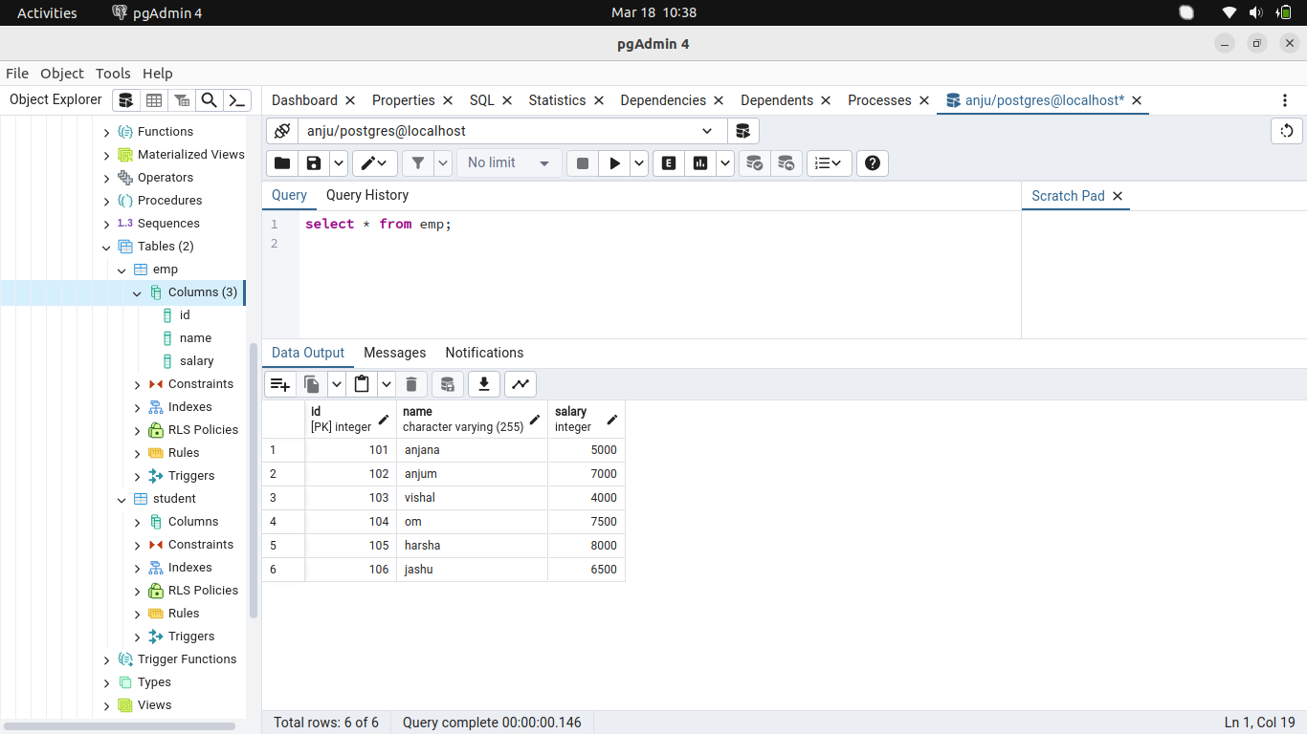
25.Write a select query with multiple conditions using ‘AND’ and ‘OR’.
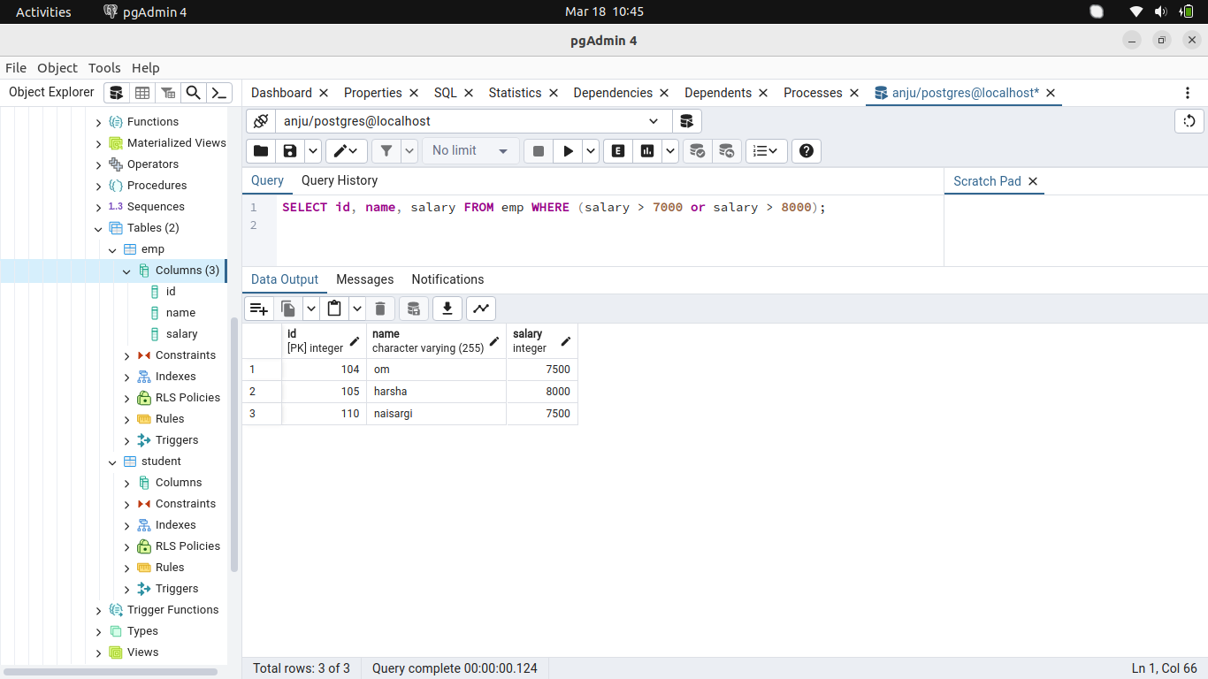
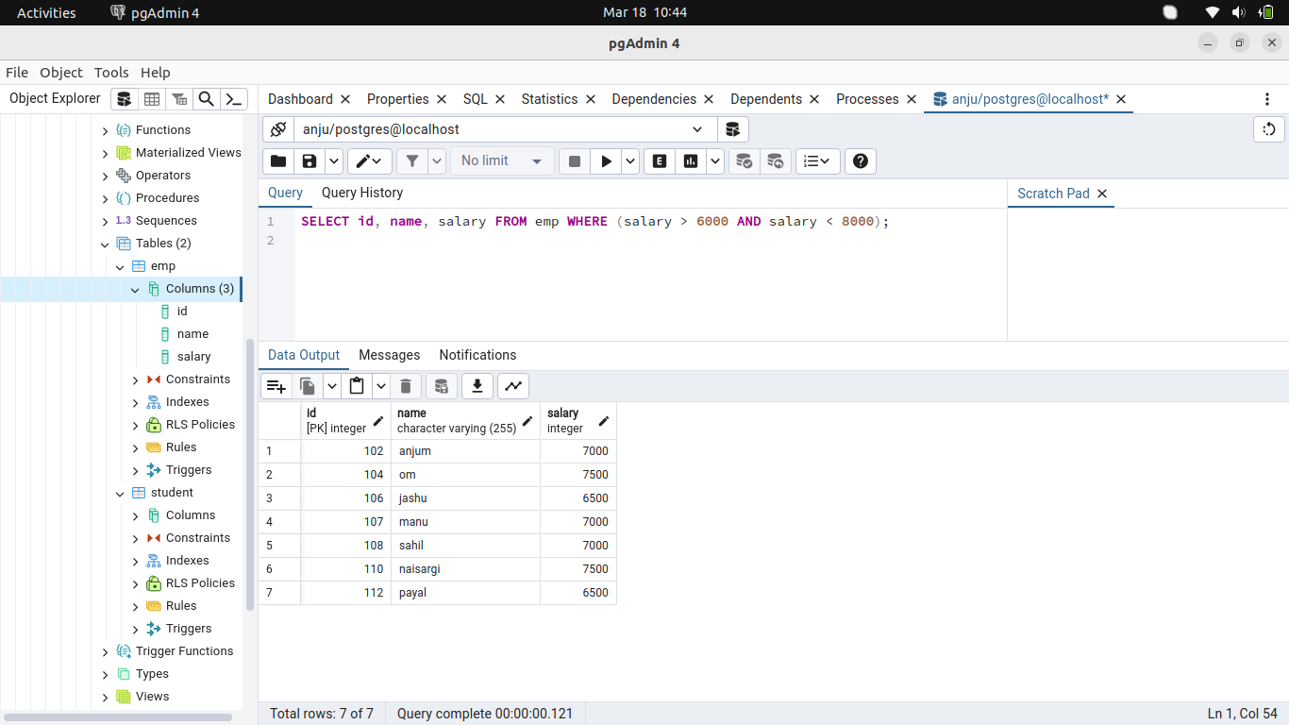
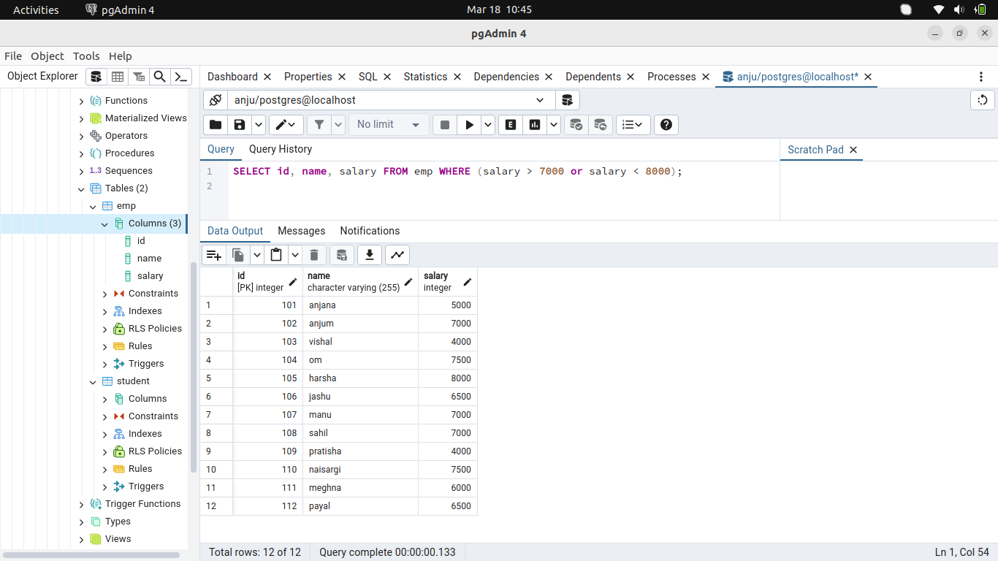
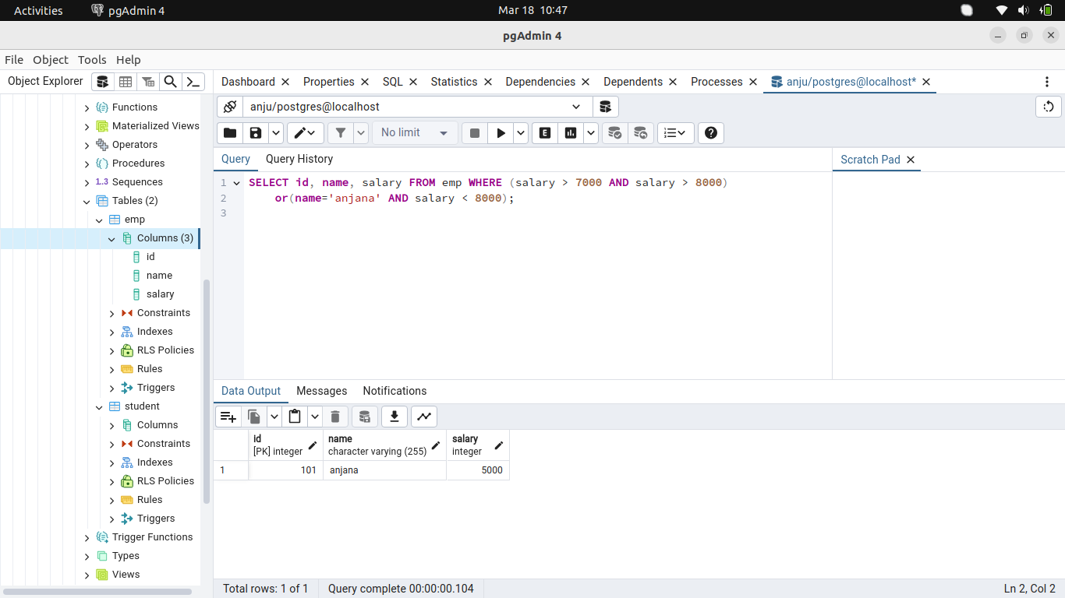
26.Create a table employee where it contains id, name, city. Find the city which ends with ‘abad’. Enter 30 records scattered in different cities like Hyderabad,Ahmedabad, Mumbai, Delhi, Chennai, Kochin, Kolkatta, Pune, Bangalore.
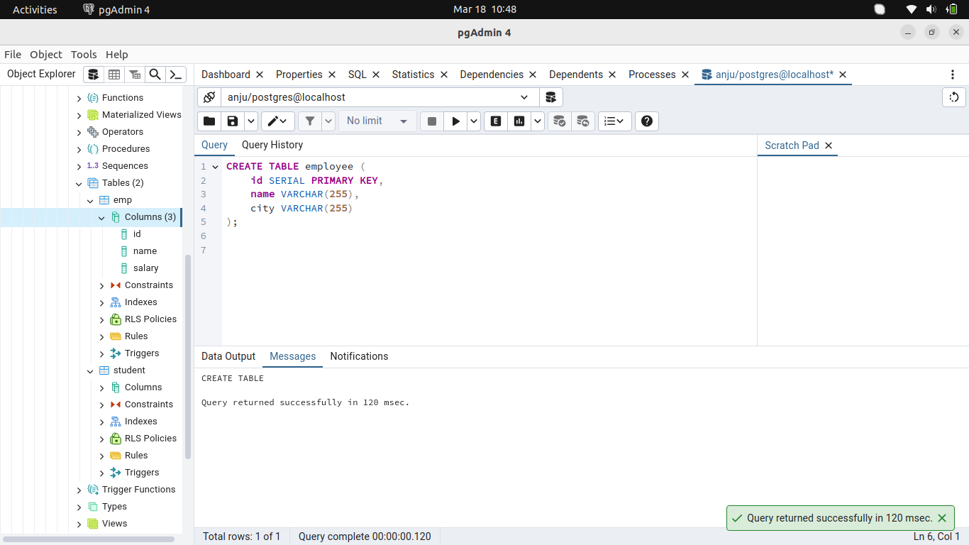

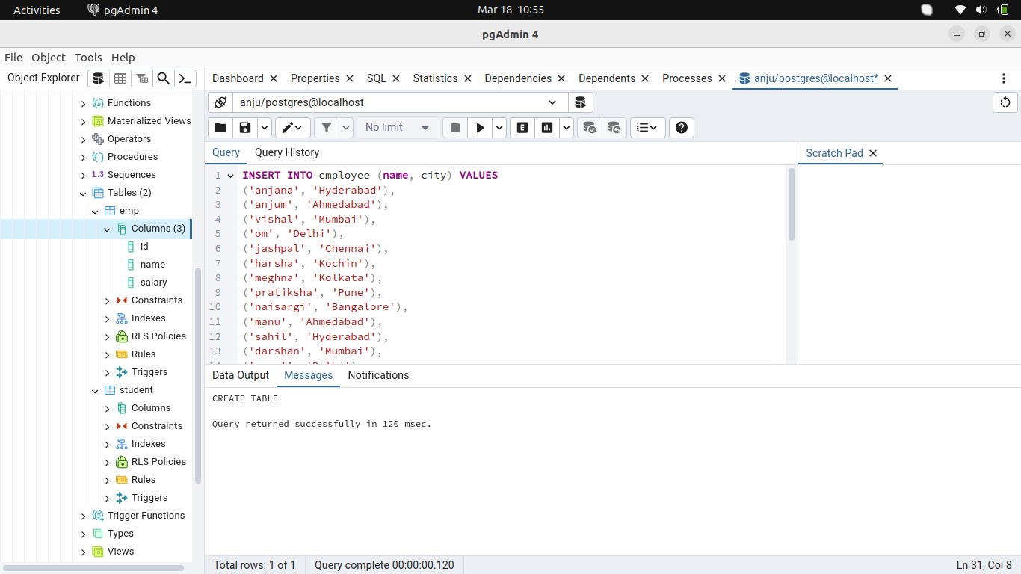
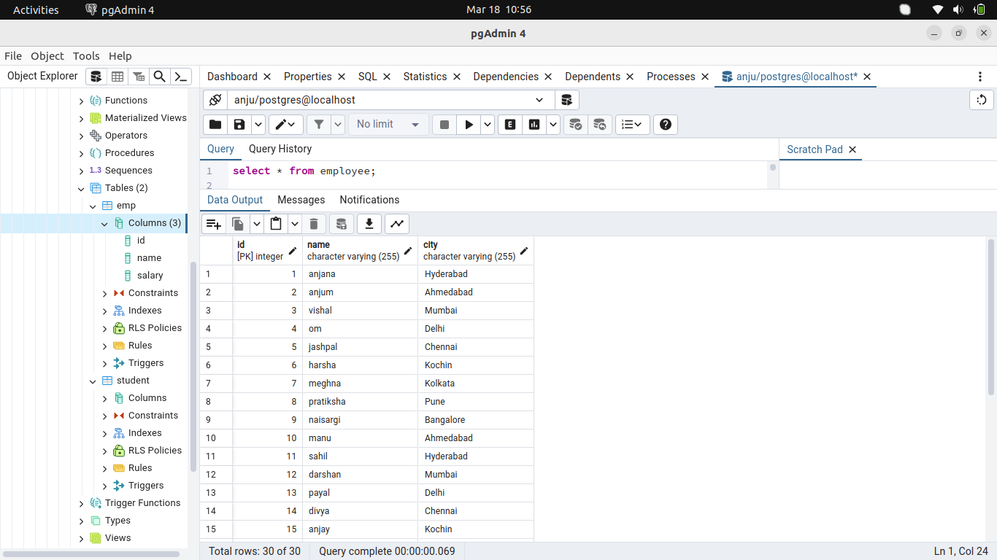
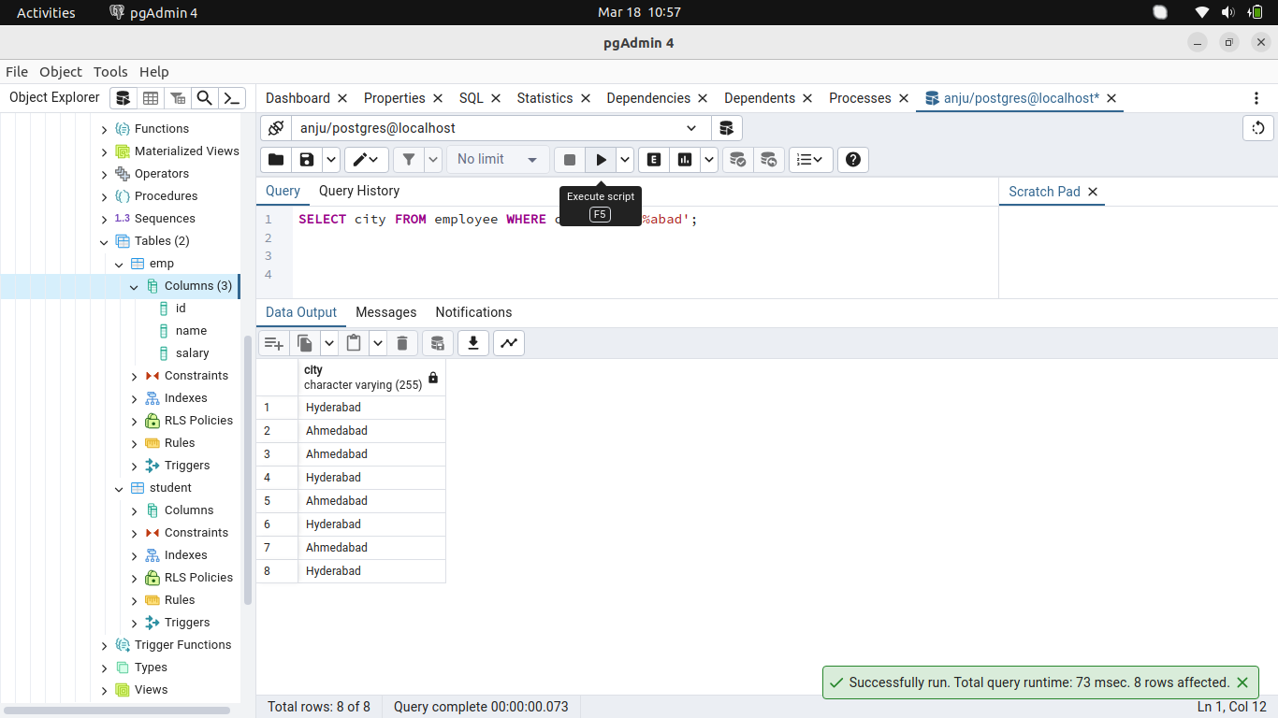
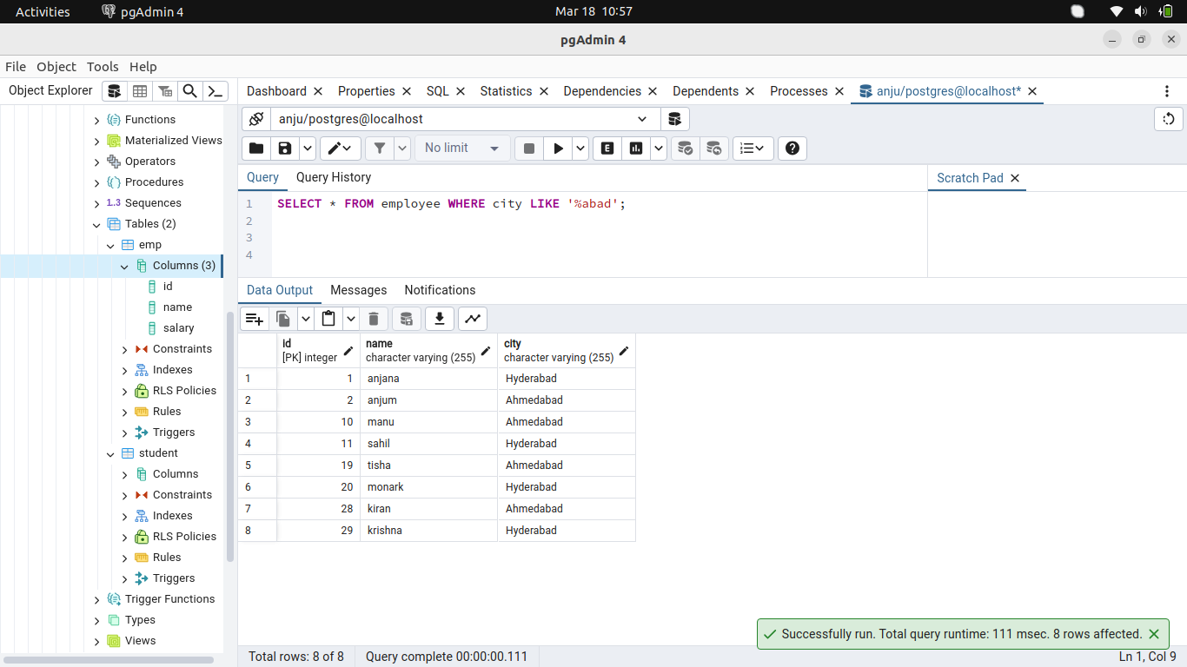
27.Search records where the city contains the string ‘under’.
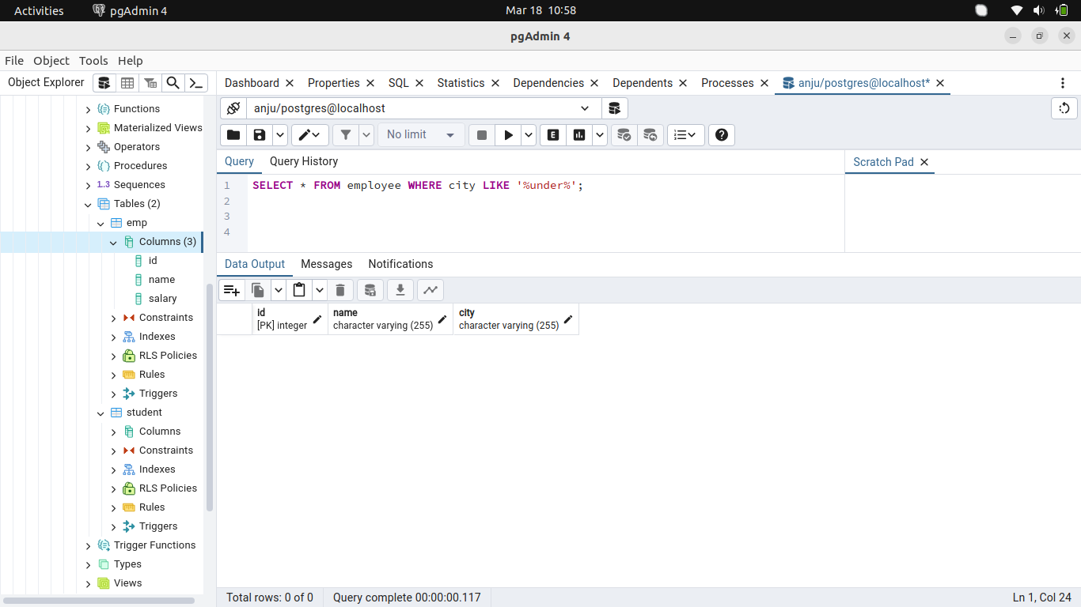
28.Search records where the third last character of the city is ‘b’.
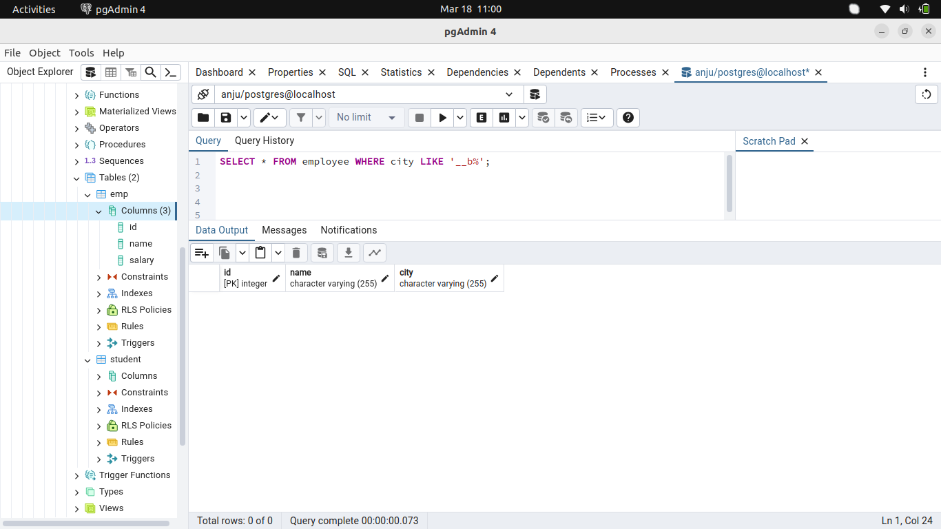
29.Search the records where first characterof the city is ‘A’.
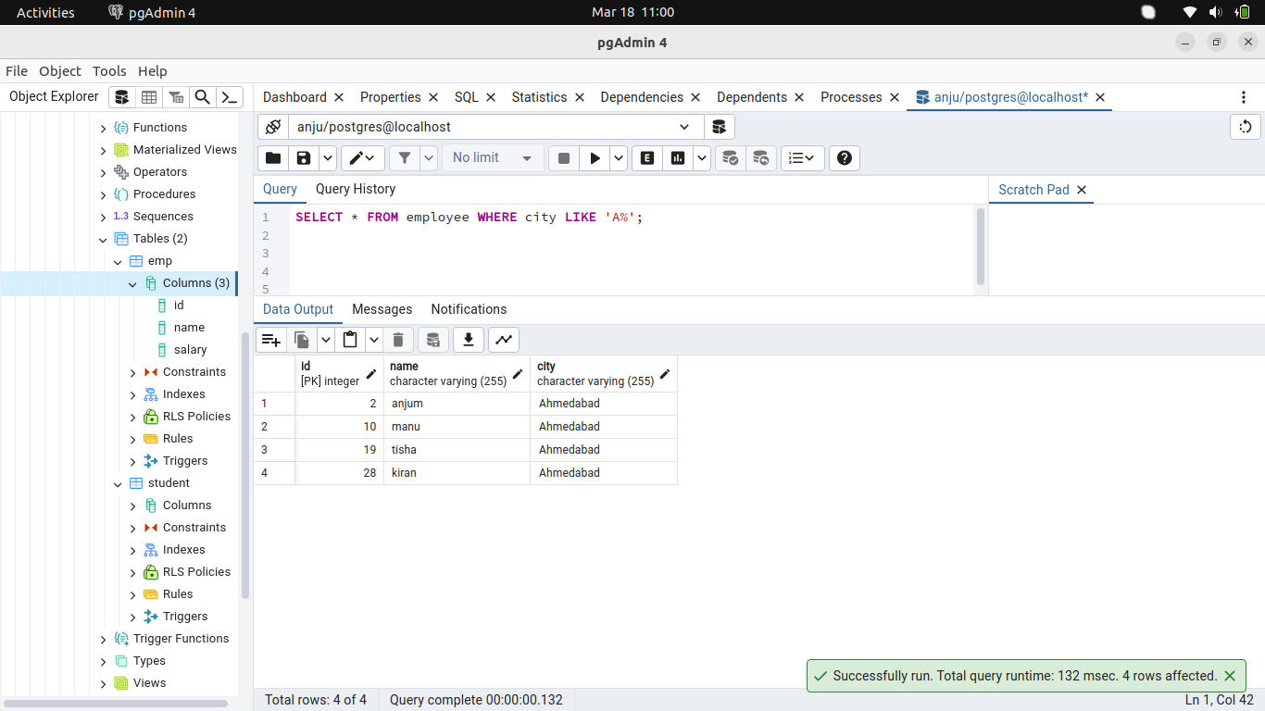
30.Search the records where second Charator of the city is ‘o’.
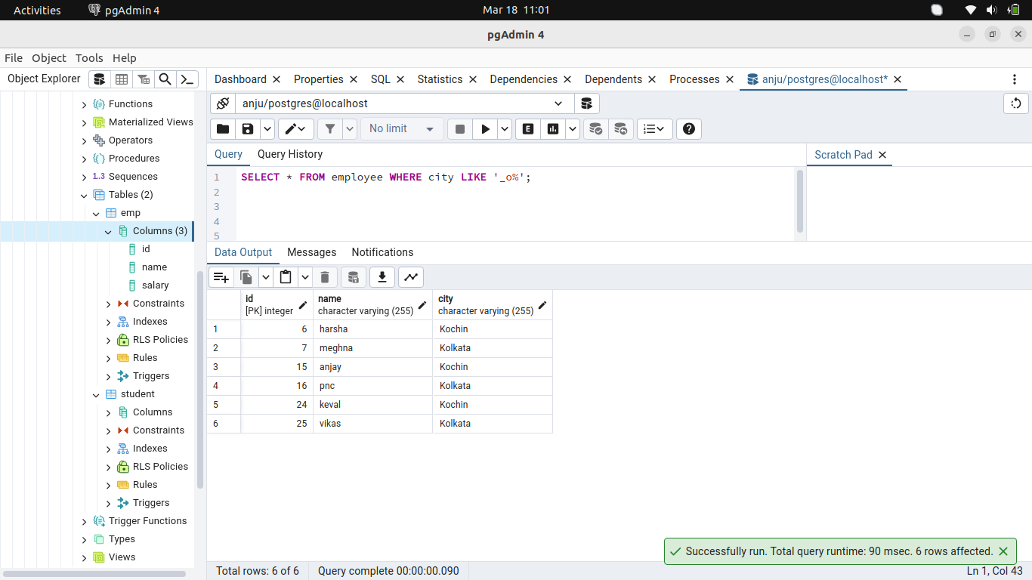
31.Search first 10 records.
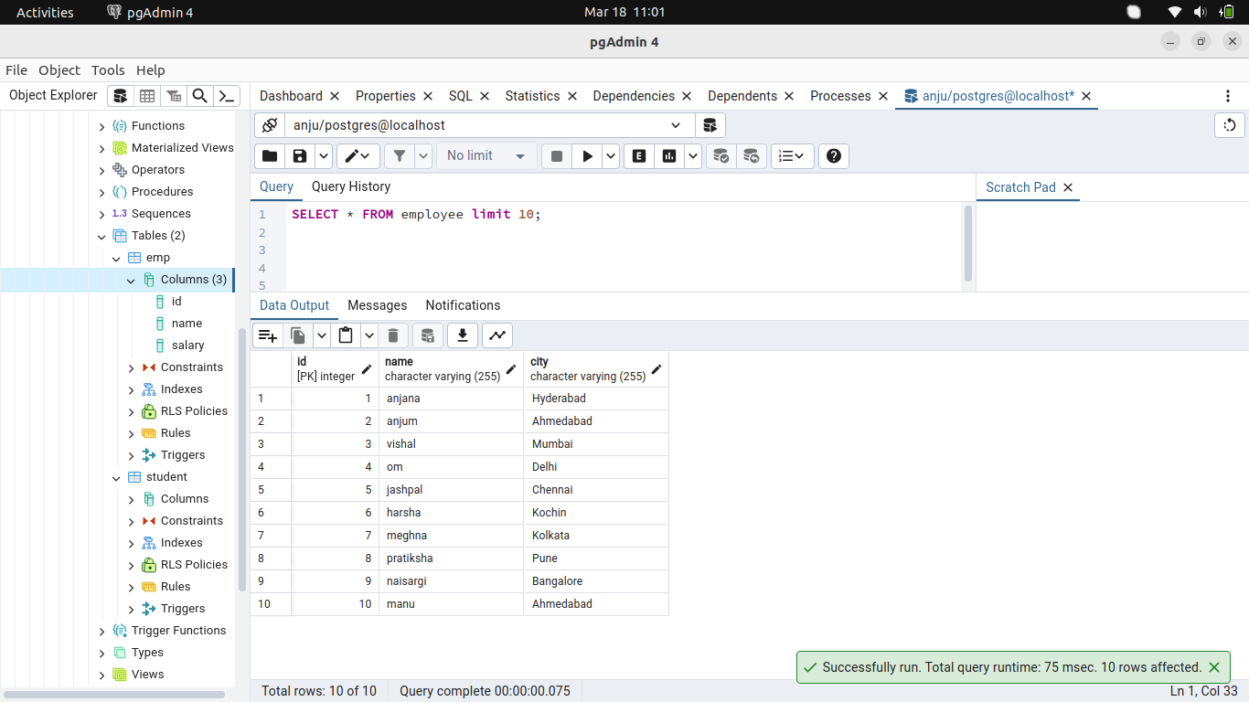
32.Search first 5 records where city is Mumbai
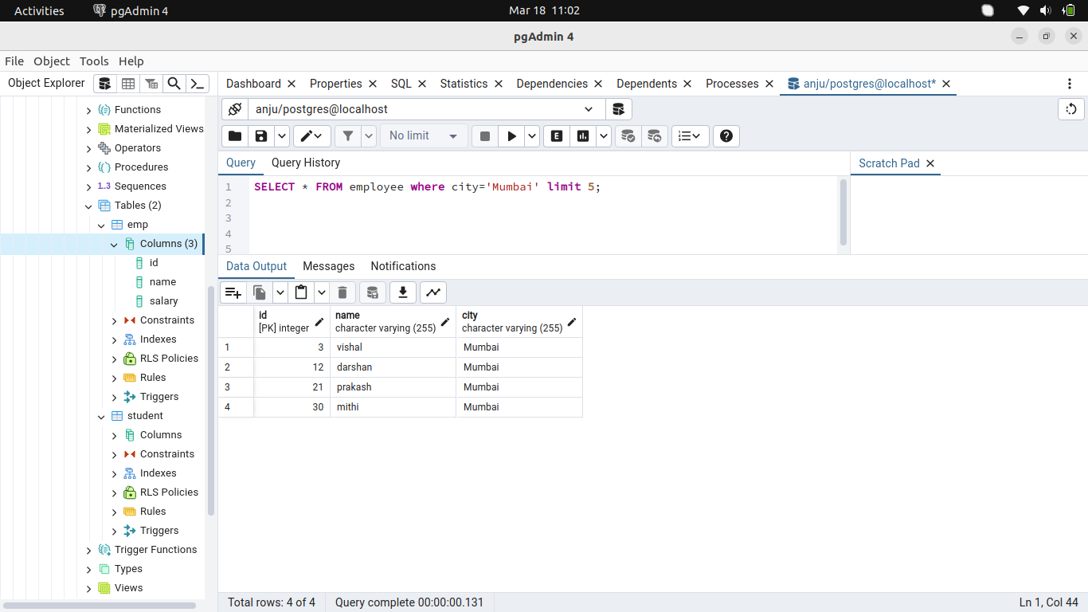
33.Search first 5 records where city is Mumbai or Bangalore.
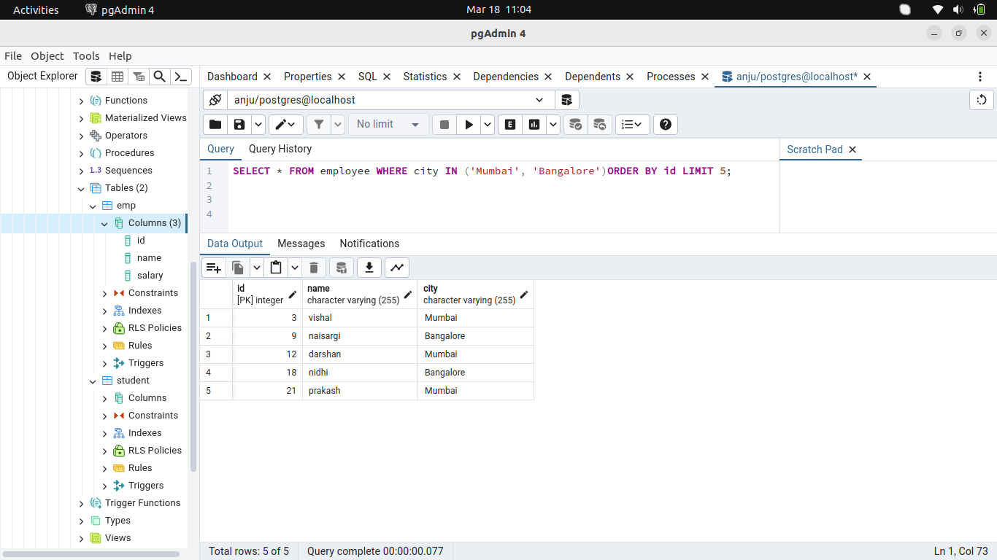
Search the next 5 records skipping the first 5 records where city is Mumbai or Bangalore.
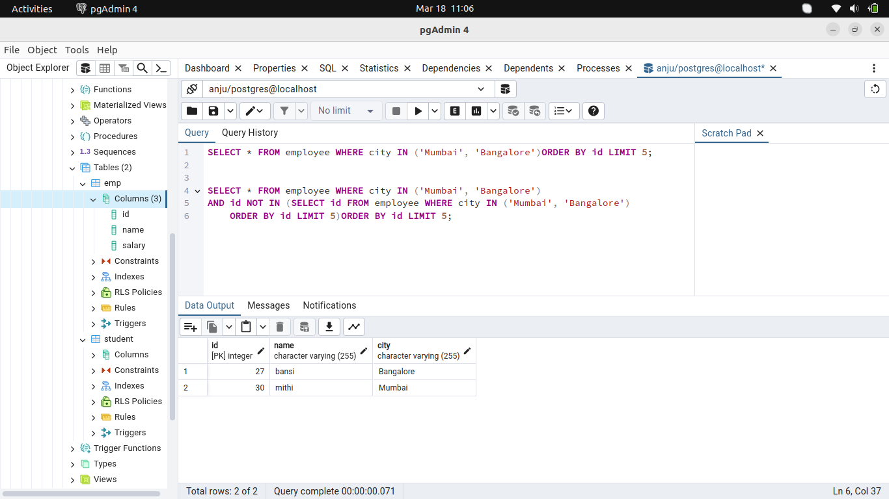
34. Sort the records where city is Mumbai or Bangalore by City Name.
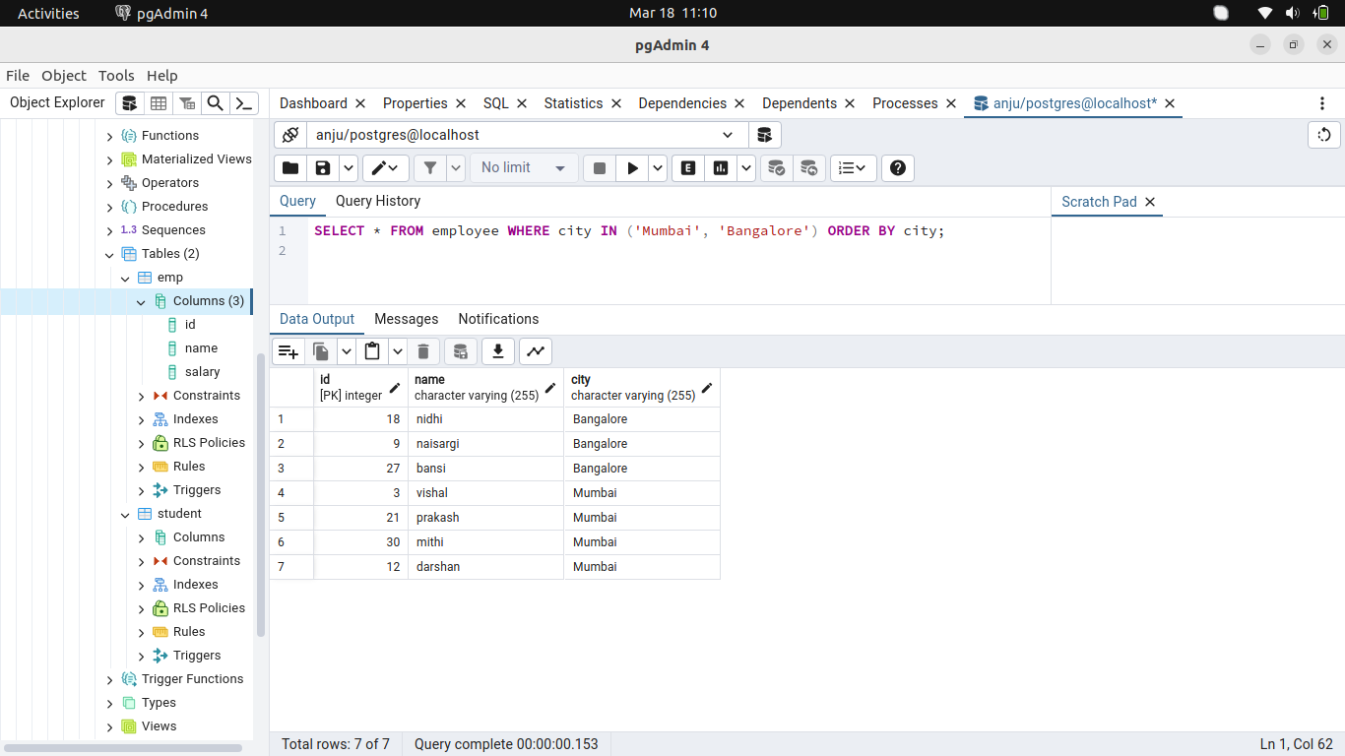
35. Sort all the records of the table by ID in descending order.
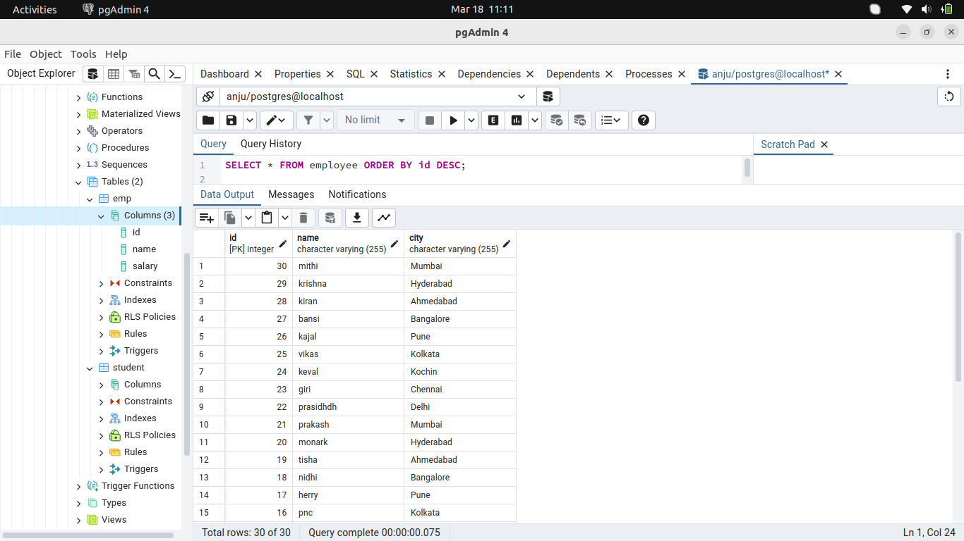
36. Insert few records where the city is not entered.
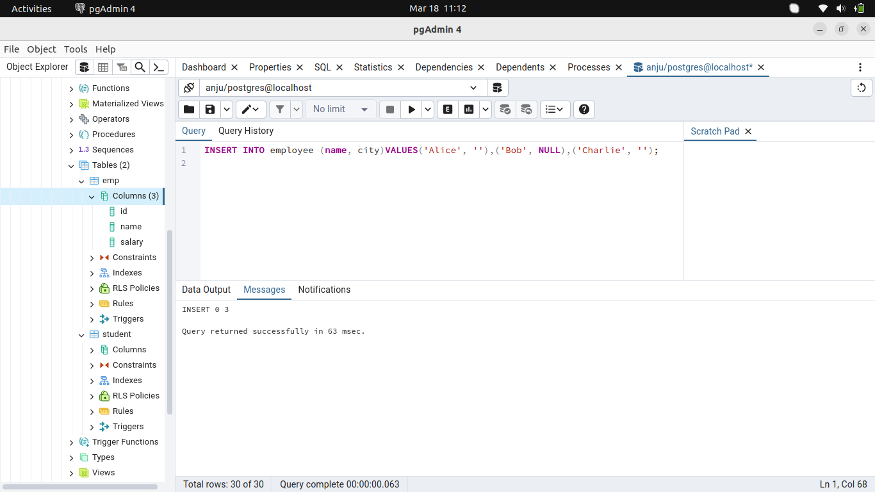
Search all the records where thecity field is blank.
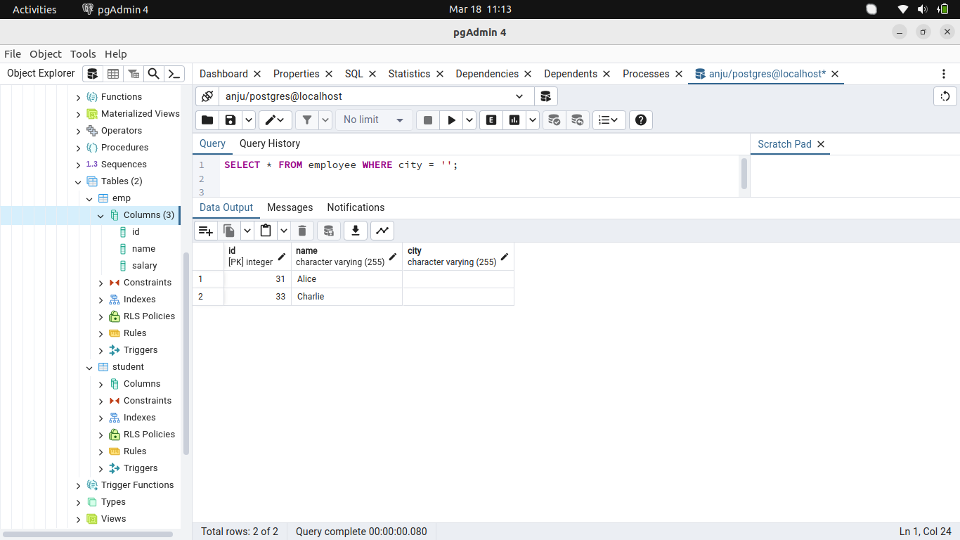
37. Enter few duplicate records where name is duplicate.
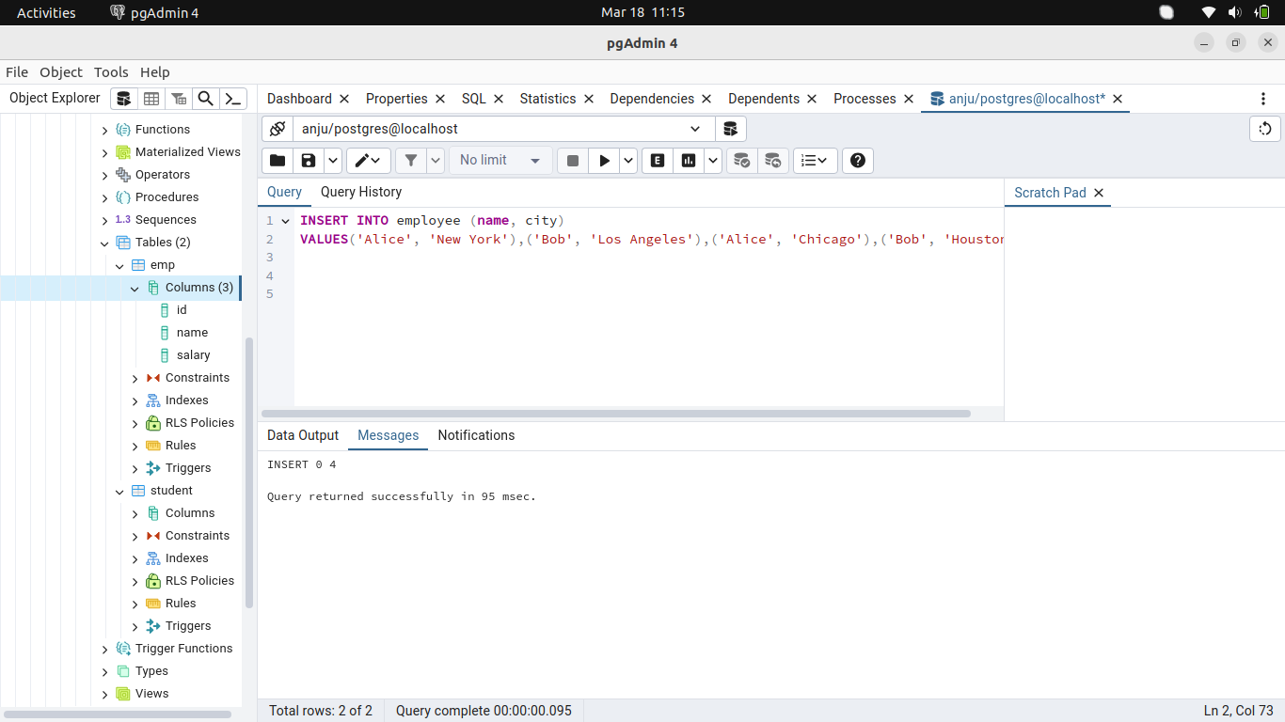
Select unique records from a table.
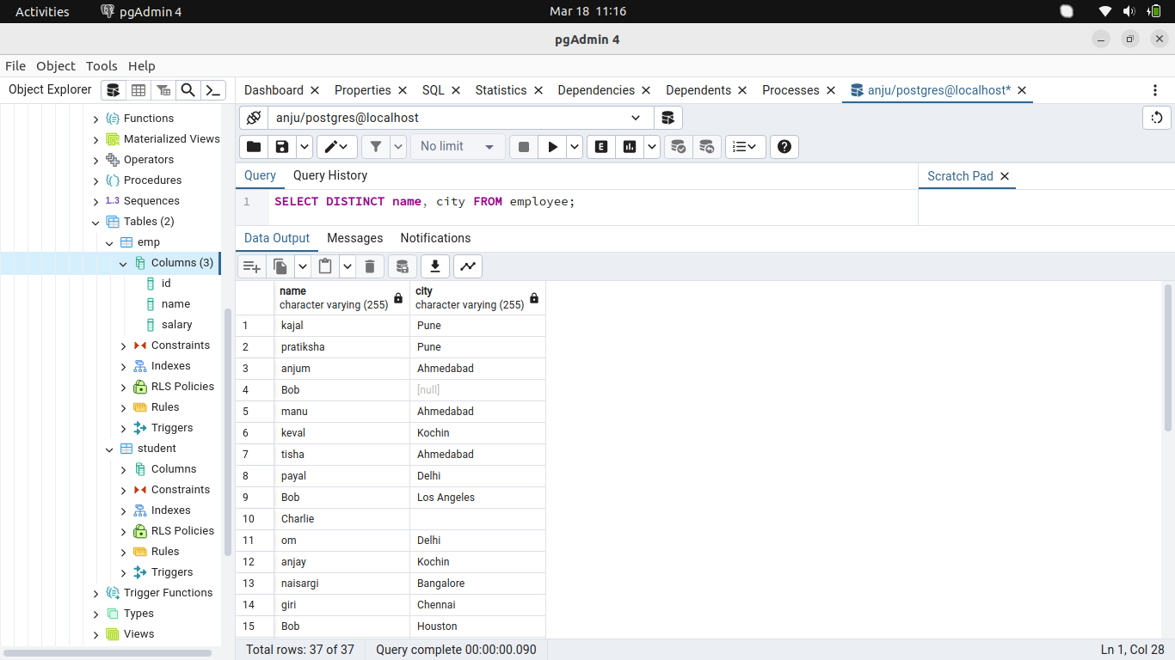
38. Enter a column amount in the table. Get a total of the complete amount.
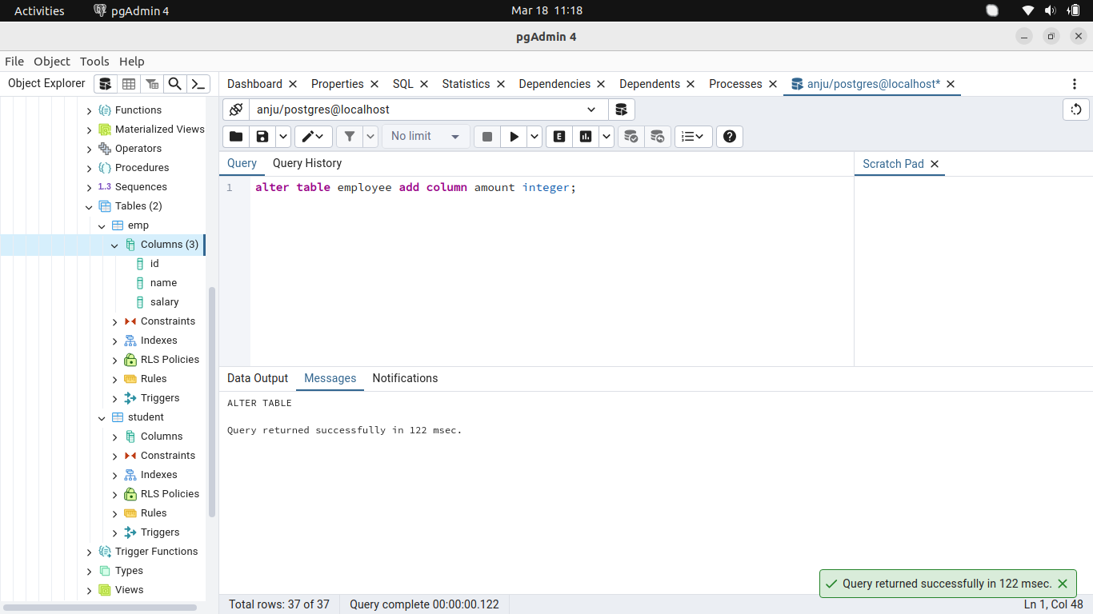
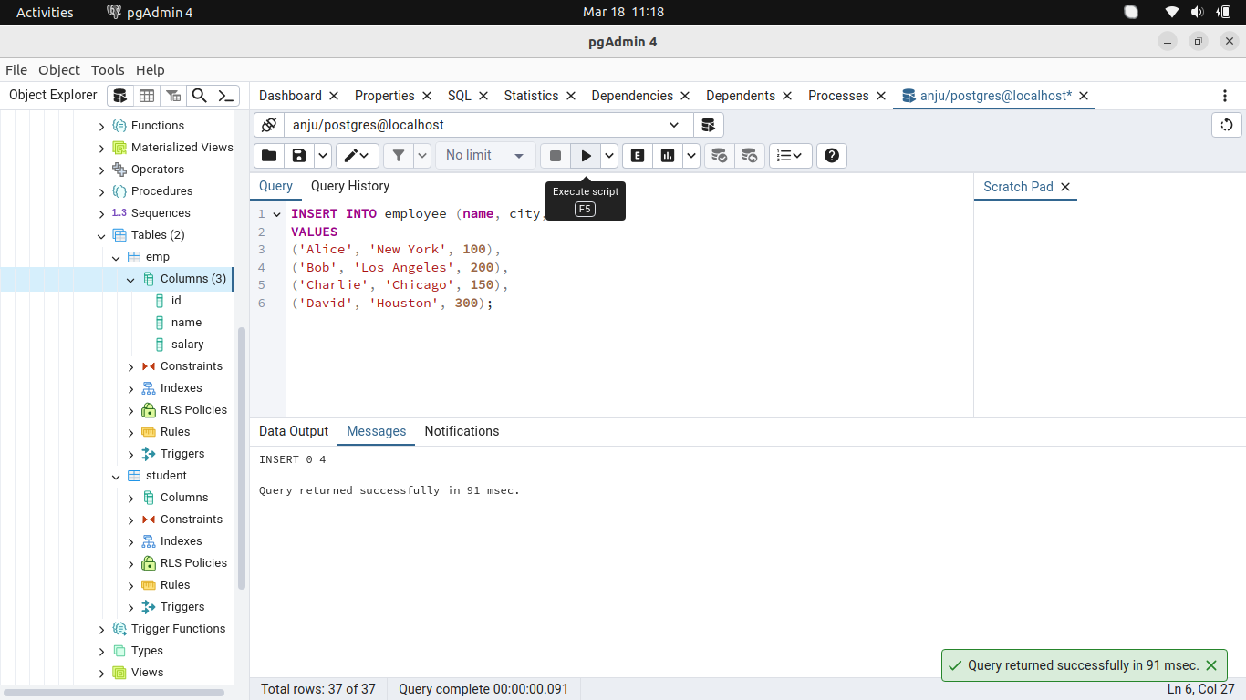
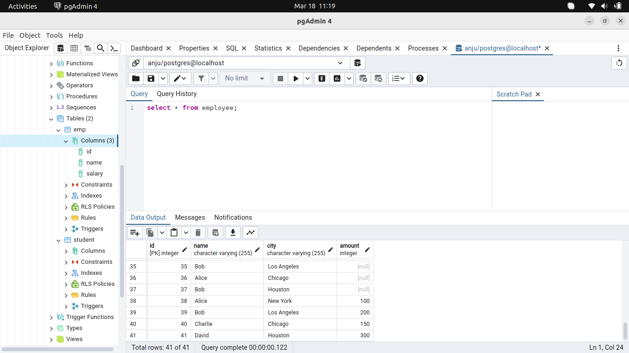
39. Get total of amount by city.
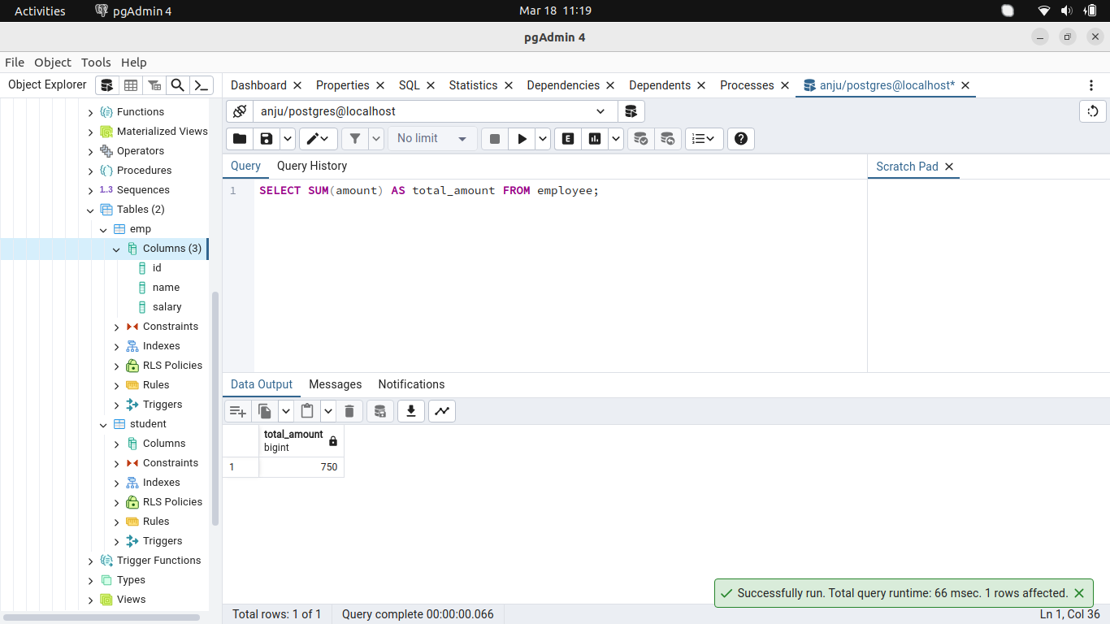
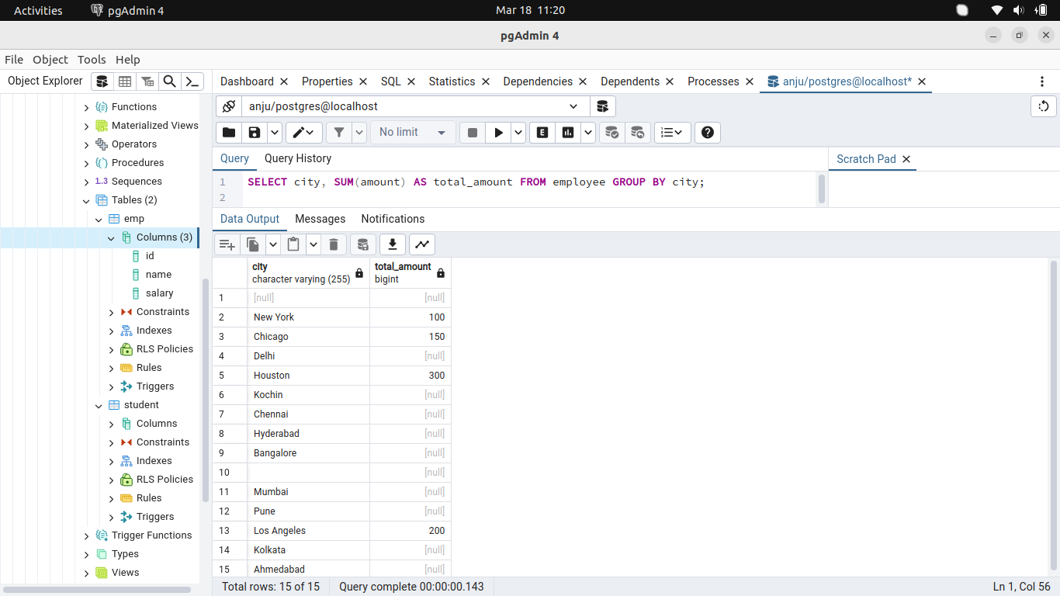
40. Get avg of amount by city.
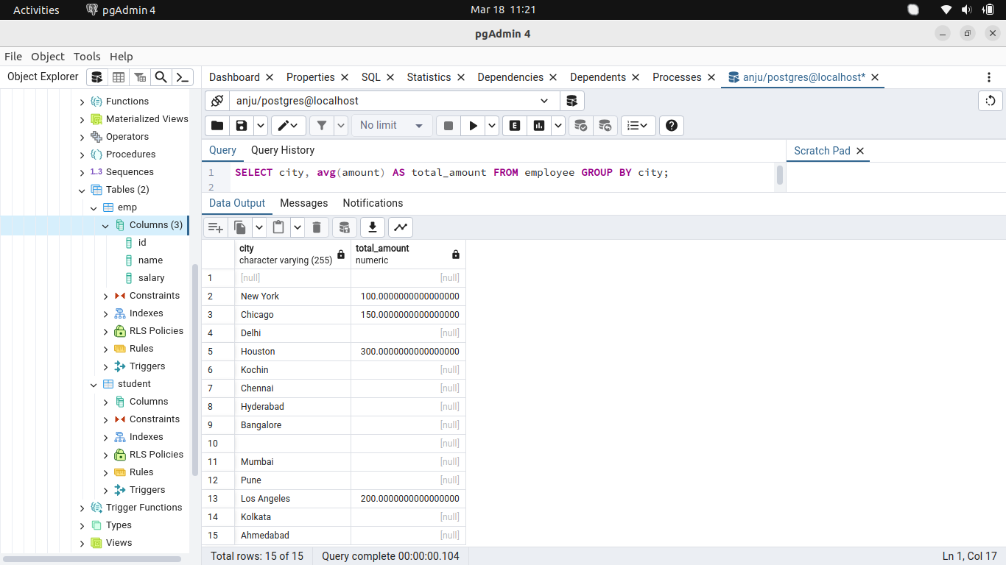
41. Get maximum amount from all records
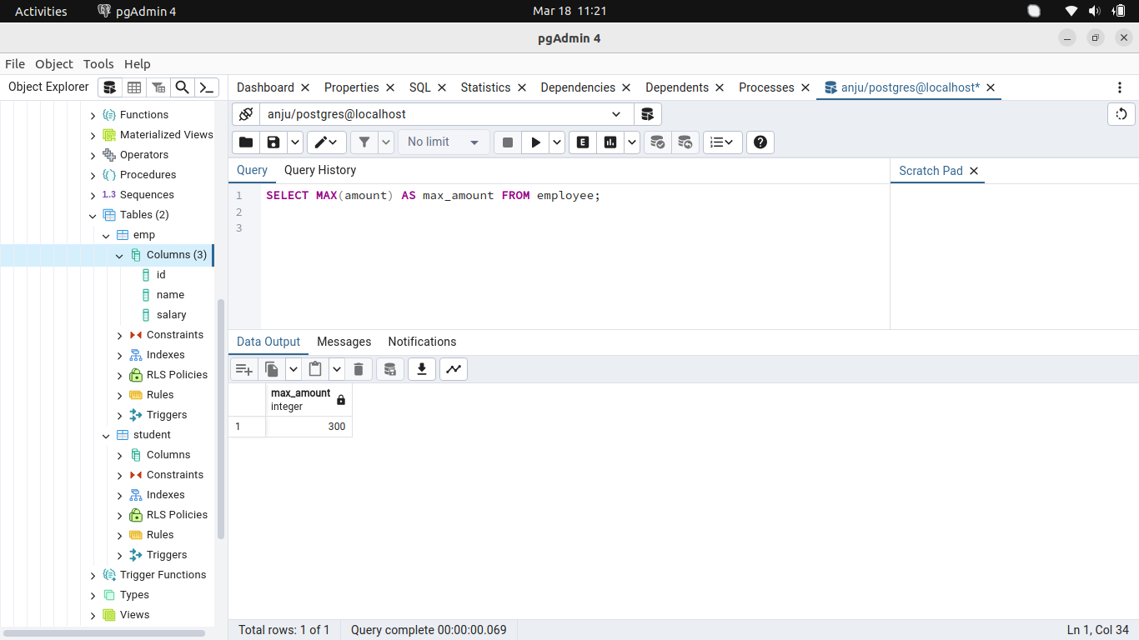
42. Get minimum amount from
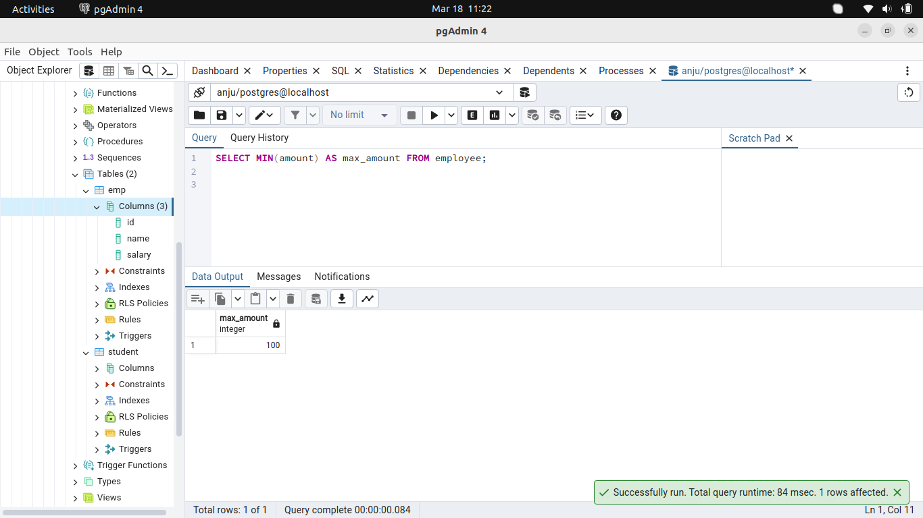
all records.

